Forum: The General Assembly
Issue: Promoting innovative ways for youths to participate in civic engagement
Student Officer: Edward Zeng and Max Tian
Position: Assistant Presidents

Introduction
Civic duty and participation are fundamental and core values in all democratic societies. Democratic governments, especially, gain legitimacy to govern from civic engagement such as voting and national service. In recent years, however, civic engagement has seen a marked decline across democratic countries around the world. The problem is most pronounced in the demographic of young adults, with a drastically lower civic participation ratio in this particular demographic compared to the general population and older demographics. Looking at Canada for example, 47% of youth aged 15 to 19 indicated that they were likely to vote in the next election cycle, compared to 84% of seniors aged 65 to 74. In the US, the 2006 National Civic and Political Health survey revealed that only about seven percent of 15 to 25-year-old adults in the United States actively participated in activities such as voting, grass-root campaigning, and townhalls that are considered to be civic engagement Together, these two pieces of statistics reveal the current appalling state of youth civic engagement. This phenomenon pertains not only to the United States and Canada but also to most More Economically Developed Countries (MEDCs) and Less Economically Developed Countries (LEDCs). Prominent political scientists prescribe this lack of civic engagement from the youth population as a combination of lacking initiative, lack of proper civic education, lack of resources, and lack of opportunities. In particular, a lack of proper political education in the school system is thought to have handicapped the proper development of civic engagement in the youth by a large quantity. A lack of trust, or the belief that one's actions cannot make a difference, is also dis-incentivizing civic engagement in the youth. It is, however, prudent to keep in mind that civic engagement also does not pertain to simply going out to vote but rather a range of activities that are aimed at making a difference in one’s community through either political or non-political processes.

Definition of Key Terms
Civic Engagement
Civic engagement is any individual or group activity addressing issues of public concern. Civic engagement includes communities working together or individuals working alone in both political and non-political actions to protect public values or make a change in a community. Examples of civic engagement could include voting, writing letters to local representatives, setting up voter registration drivers, or organizing demonstrations.
Civic Participation
Civic participation can be used interchangeably with civic engagement and thus has the same definition as the previous term.
Civics
Civics is a social science that focuses on the study of the rights and duties of citizens.
Civic Duty
Civic duty is the set of responsibilities citizens of a nation or community have the obligation of carrying out. Examples of civic duty include actively voting in elections, or joining the military when drafted.
Demographics
Demographics is statistical data relating to a country’s population and specific groups within it. Statistical characteristics such as age, income, or race are used as markers to identify specific groups in a population. For example, young adults aged 18-24 are a demographic.
Citizens
Citizenship is a legal status and relation between an individual and a state that entails specific legal rights and civic duties. Citizenship is gained by meeting the legal requirements of a national, state, or local government. A nation grants certain rights and privileges to its citizens. In return, citizens are expected to obey their country's laws and carry out their civic duty.
Voter turnout
Voter turnout refers to the particular participation rate of a given election compared to the total number of eligible voters. A low voter turnout indicates that there are fewer people voting, while a high voter turnout indicates that more people are voting. In democracies, a high voter turnout is more desirable as it more accurately conveys the will of the people.
Civic Desert
A term to describe places where there are few to no opportunities for people to meet, discuss issues, or address problems of concern to them. Essentially, civic desert are communities without opportunities for civic engagement. Civic desert are most commonly seen in rural communities that sees high levels of population loss, and are formed mostly unintentionally.

Population
Population refers to the total amount of citizens within a community or country. It can also refer to the total amount of individual within a specific demographic of people.

Background
As established in the introduction, civic engagement has seen a marked decline in recent years, especially among the youth demographic of populations. This is also a problem faced by many countries across the world, not just in specific regions or types of government. A study by the Harvard Kennedy School of politics suggests that less than 10 percent of Americans between 18 and 24 met a standard of “informed engagement”, a level of civic knowledge deemed satisfactory, in the 2012 presidential election cycle. The figure below displays the voter turnout ratio of eligible adults aged between 18-24 in the past few presidential elections. We can see that voter turnout of this demographic has declined steadily in the US except for the last election cycle of 2020. These two pieces of statistics both paint a bleak picture of civic engagement in the US youth. This trend, however, is not limited to the US alone and is replicable throughout the world in different countries. Political scientists have also deemed a high level of civic participation from all demographics of a population as crucial to the well functioning of democratic society and government. “The health of a democratic society may be measured by the quality of functions performed by private citizens”, Alexis de Tocqueville, a famous political scientists and philosopher, wrote in Democracy in America.
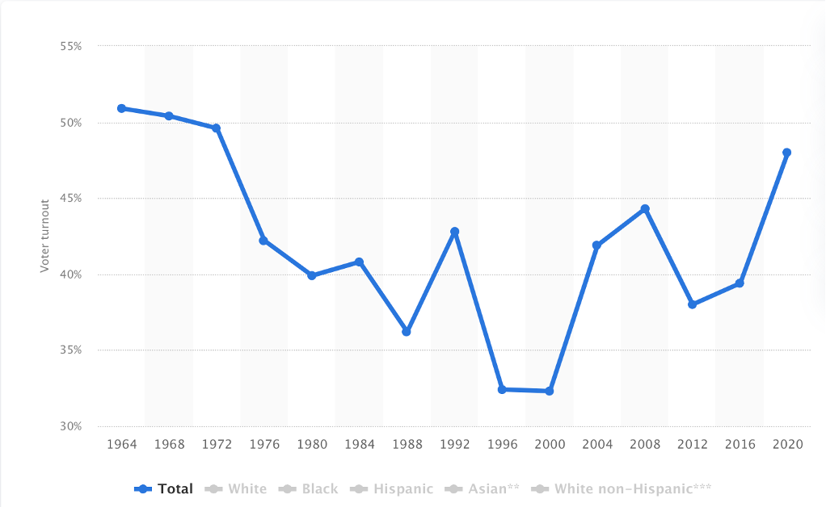
Figure 1 voter turnout ratio of eligible adults aged between 18-24 in the past 15 presidential election cycle
Lack of proper civic education
In many countries, a floundering public education system has failed in properly teach civic knowledge to the Youth. In the US for example, only 23 percent of eighth-graders performed at or above the proficient level on the National Assessment of Educational Progress (NAEP) civics exam. The absence of proper civic education handicap young adults from fulfilling their civic duties and understanding them. Without understanding civic duty, few young adults will take the time and effort to participate in civic engagement. This line of thinking has been validated by numerous social experiments, with political scientists now believing that proper civic education is critical to increasing civic engagement among the youth as discussed by Trey Grayson, former Kentucky Secretary of State (R-KY), and director of the Harvard Institute of Politics: “Research shows that civics education works. Discussing controversial issues, engaging in service learning if it involves discussion of ‘root causes,’ being contacted by parties and campaigns, and participating in extracurricular groups all predict good civic outcomes for students.” As such, delegates should investigate innovative ways to better boost civic education in the youth as a pretext for raising overall civic engagement.
Distrust in government
There is no doubt that youth globally have become increasingly skeptical of traditional establishments of government and doubted their true intentions. In the UK, only 1 in 5 young adults surveyed reported high levels of trust in the civil service, British government, or elected politicians. In the US, the situation is even bleaker. According to a new Harvard study, no single political institution in the US had achieved a level of trust of 50 percent or above in the age group between 18-29. And in the diagram below, we see that trust in major government institutions among American youth has seen a steady decline between 2010 and 2014, at an appalling 31% in 2014. With declining trust in government comes declining youth civic engagement. If citizens, especially young citizens, do not even trust the government and pollical system they live in, how can they possibly participate in civic activities that involve dealing with governmental institutions? The problem is that most civic engagements involve some level of trust in existent institutions for citizens to participate in. How can you vote if you think the system is rigged?
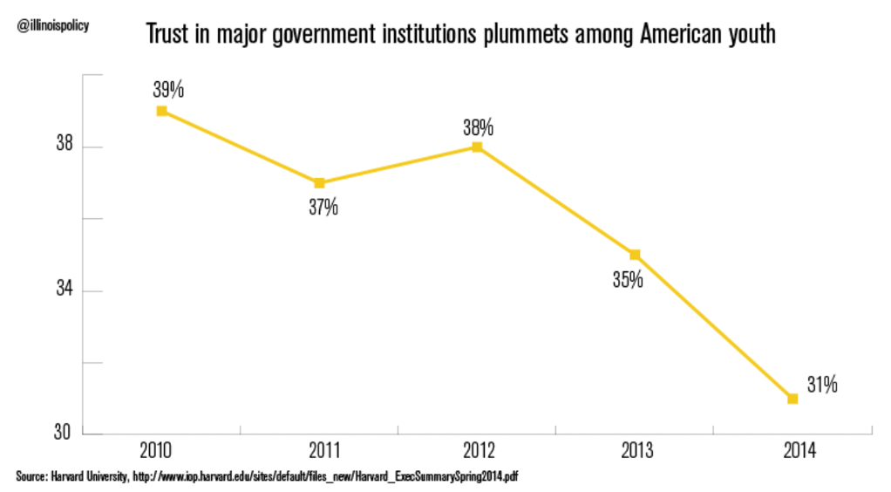
Figure 2 Trust in major institutions of young Americans

Lack of opportunities
Another reason that political scientists attribute to the declining civic engagement of young adults is simply the lack of opportunities. Of particular concern is the rise of what political scientists call “civic deserts,” namely places where there are few to no opportunities for people to meet, discuss issues, and participate in civic activities. A report by the National Conference on Citizenship estimated that more than 60 percent of all rural youth live in civic deserts, along with 30 percent of urban and suburban young Americans. In rural Europe, a survey given to NGOs working on civic engagement-related issues revealed that 72% agreed that where they worked could be classified as a “civic desert.” Thus, the problem faced by many youths is that they simply lack the opportunity to participate in civic engagement. This lack of opportunity is a major obstacle in resolving low youth civic engagements across the globe. As a result, delegates should look to innovative methods in addressing the rise of the so-called “civic deserts”.
Stale Political Climate
A stale political climate, meaning political systems that have dominant electoral parties, has also been shown to reduce the likelihood of civic participation in many parts of the world. The US in particular suffers drastically due to this issue. The existence of solid red states or solid blue states discourages voters by implying individuals’ votes don’t matter. To a young adult living in California, voting or not voting will all yield the same result. In their view, going out and participating in civic activities such as voting does not impact their lives. As such, seeing that their efforts have no outcome, youth will naturally be dis-swayed from civic engagement.

Major Parties Involved

UN civil society

The UN civil society is within the Outreach Division in the United Nations Department of Global Communications. Its main task is to work with local Civil society organizations to promote UN values and civil knowledge.

Civic Nation

Civic Nation is a major Non-Governmental Organization in the United States that focuses on engaging young people to take a more active role in politics and civil affairs.

United States of America

America has been experiencing low voter turnout and civic engagement since the 1980s, with little results after repeated efforts to address the issue.

The European Union

The European Union (EU) has attempted to implement certain strategies to promote civic engagement among the youth population of Europe. Their main methodology in accomplishing such target is the Erasmus+ - the EU program for education, training, youth and sport. The mission of this organization is to facilitate “activities outside formal education and training that encourage, foster and facilitate young people’s participation in Europe’s democratic life at local, regional, national and European level.”

Timeline of Events
Date | Description of event
1949 | Founding of the Council of Europe
1970 | Creation of the United Nations Volunteer Program (UNV)
1989 | United Nations Convention for the Rights of the Child
1990 | Start of the Student Anti-Sweatshop Movement (SASM)
2007 | Introduction of the Global Learning Program to multiple countries
2012 - 2017 | UNV donates more than $20 million USD on programs to enhance youth participation

Previous Attempts to Resolve the Issue
Despite the ongoing conflict with debate over possible methods to deal with this matter within this field, certain methods that have already been implemented have deeply impacted the question of promoting innovative ways for youths to participate in civic engagement in a very positive manner. These methods include requesting the government to monitor the current civic engagement of the youth and act upon the lack of activity, the formation of certain interventions and social groups that encourage the rights for the youth and emphasize those benefits, and also mostly through means of educating the youth and also the public about the current situation.
Firstly, the United Nations Convention for the Rights of the Child was created in 1989 to defend children’s’ and youths’ rights to free speech. This was the first monumental step in promoting the civic engagements of the youth because they could contribute to the ideas of society without having to worry about being harmed. Following this idea, there are many institutions and organizations that follow the same idea as these conventional rights. Recent organizations such as “Generation Unlimited” and the “Global Initiative on the Decent Jobs for Youth” are two multi-stakeholder alliances working together to mobilize action and foster skills, employment and the meaningful participation of young people across the world. These organizations and others have specifically benefitted the youth and their communities through providing opportunities to the youths that they did not have before, and this is evident through observation in certain areas: “There has been greater youth participation and contribution to decision-making in city and district councils in Sierra Leone since the end of the civil war.”
Secondly, the large majority of the public has largely relied on the government during the recent years due to the COVID-19 pandemic. The communities relied on the awareness of governments to initiate and supervise the conditions and rights of the youth that enable them to speak out on the issues that will impact them. Both the government and the United Nations argue that increased youth civic engagement leads to direct benefits for the youth such as improved mental health and healthy behaviors, higher education outcomes and generally more positive experiences within their communities and also provided a higher quality of life. People around the world have not only relied on their country’s government but also on the United Nations. In the past years, the United Nations have had consultations concerning the benefits of youth civic activity. The UN has encouraged the upbringing and frequency of certain types of activities. These activities include volunteering through means of more diverse forms of engagement around national issues through social media, public fora, and activities supporting local causes. Between 2012 and 2017, the UNV and its collaborators have donated more than $20 million USD on programs to enhance youth participation in sustainable development and the promotion of peace and stability. In addition to all the above points, efforts to provide youth with equal education increases the awareness of the importance of youth civic engagement. By bringing young people together with governments, social partners, the private sector, and a range of international and local organizations, they connect traditional education and training to a complex and fast-changing world, while easing the transition of young people into decent jobs. However, there are also some young people that act individually. These people include activists Malala, Greta Thunberg, etc. When people take individual initiative, it inspires others to follow in their actions.
Finally, governments have helped promote innovative ways to encourage youth civic engagement through various non-mentioned methods; fostering laws, policies and budget allocations supporting youth engagement; supporting, creating, and sustaining structures for young people’s participation and civic engagement; instituting global citizenship education including curricula and teacher training; investing in young people’s capacities and partnerships including youth led movements, initiatives, and networks; maximizing the value of volunteerism and community service.
Fostering laws, policies and budget allocations include being supported by legislative and policy frameworks and requiring a national civic service. For example, students will have to perform a certain period of service after they graduate from school which has already been implemented in various nations. Others include participatory budgeting activities and service learning within school communities. Supporting, creating and sustaining structures for young people’s participation and civic engagement includes the utilization of school councils and student unions, youth parliaments, co-managements bodies, youth participation in trade unions, and youth participation in the private sector. Instituting global citizenship education including curricula and teacher training mainly includes teaching the importance of youth civic engagement to students within school. Other already implemented methods such as investing in young people’s capabilities, networks and partnerships including youth led movements, initiatives, and networks have been performed through education, communication, youth-led initiatives and movements, and also through digital media. Lastly, maximizing the value of volunteerism and community service mainly includes implementations of volunteering and service learning.

Possible Solutions
The question of promoting innovative ways for youths to participate in civic engagement calls upon four main groups of people. These groups include the youths, political leaders and policymakers, business leaders, and social partners. Through the awareness of these groups towards this main issue, methods to increase youth civic engagement will see an increase.

Firstly, to address the issue of this issue, young people have to be aware that they have the power and the rights to lead civic engagement from the front and also be aware that they will be supported with their actions. They have to be aware that they can take initiative when it comes to making choices in their community that will impact themselves. Therefore, some of these methods include taking action to improve their societies, engaging in governance structures, getting active online and getting engaged in local communities. Through these ways, they can advocate for themselves and also put themselves in a position that makes other social groups more aware of this issue at hand.
Another group that possesses the power to infiltrate this issue is political leaders and policymakers. These people can change the legislations of a country to allow more active civic engagement from the younger generations. Political leaders and policymakers should view the youths as partners they can collaborate with to achieve a greater good. Leaders and initiators who do not see it this way will not be able to reap the benefits that the active youth will supply. Therefore, leaders should work towards shaping an enabling environment for young people’s participation and civic engagement through the use of laws, policies, and budget allocations. Other methods that policymakers and political leaders can make include the creation and strengthening of governance structures and platforms in schools, workplaces, local communities and politics. They should also mainstream global citizenship education in both formal and non-formal settings and invest in young-people’s capacities, networks, and partnerships which includes provisioning space and opportunities for the youth. Especially during the time of the pandemic, it is most vital that the youths in various communities can be included within the decision making process through these methods stated above. Lastly, as the world is changing, so is social conduct so policymakers and political leaders need to be promoting and protecting young people’s rights constantly.

The third group that can address this issue at hand are social partners. Social partners are important when it comes to promoting innovative ways for youths to participate in civic engagement because they have the most power when it comes to advocating for the youth. They can co-create and design their programs and services with adolescence and young people. They can promote and encourage greater participation and representation of a diverse range of young people in their organizations and they can also strengthen initial and continuous training of social workers, on how to teach young people the skills for civic engagement and participation. These social partners can also be supported by both the UN and respective governments. Through these specific methods, social partners can encourage the youths to engage in civic activity and also promote awareness to other groups about this issue. Raising awareness to other groups is also important because it also enhances the chances for youths to participate in civic engagement. Raising awareness among employers and employees, shareholders, and associates about the rights of young workers allows them to give the youth more chances to speak up and take more initiative. Along these lines of advocation, social partners should also work to advocate meaningful engagement of young people to further encourage them to take action.

Finally, the last group of people that can act towards this issue at hand are business leaders. Similar to social partners, business leaders have the power to advocate for youths to participate in civic engagements, but they also have the capital to put such plans into action. Business leaders can provide opportunities to connect youth to business network and markets and they can also support leadership development program for young people. Lastly, they should invest in multiple mentoring, leadership, and collaborating opportunities for young people. Through these methods, they can physically allow youths to participate in civic action and solve problems as societies.

Bibliography
https://www.generationunlimited.org/media/3021/file/Action%20Guide%205:%20Young%20people%E2%80%99s%20participation%20and%20civic%20engagement.pdf

https://civic-europe.eu/ideas/promoting-youth-civic-engagement/

https://youth.gov/youth-topics/civic-engagement-and-volunteering

https://youth.gov/youth-briefs/civic-engagement-strategies-transition-age-youth-2

http://afterschoolalliance.org/documents/issue_briefs/issue_civic_engagement_73.pdf

