Forum: General Assembly
Issue: Evaluating the impact of COVID-19 on the global youth population
Student Officer: Eva Chan
Position: President

Introduction
On April 16, 2022, United Nations Secretary-General Anionio Guterres released a policy bulletin on the impact of the COVID-19 pandemic on the global youth population. Guterres stated in his speech that “the pandemic has led to the most severe crash on the poorest and most vulnerable children in society”. He expressed particular concern for the well-being of children worldwide. The director of the United States Health Bureau warned that there was a mental health crisis among young Americans. The report released on April 16, 2022, highlighted the four risks (education, food, security, and health) faced by the children. In the context of the global epidemic, we must offer priority and deepest concern to the global youth group, namely children and tenagers.
On the eve of International Youth Day, the International Labour Organization, affiliated with the United Nations, released the Global Youth Employment Trend in 2022. The report points out that the employment recovery of young people aged 15-24 around the globe collapsed, and the negative impact of Covid 19 on young people is greater than that of any other age group. Globally, there are gender and regional inequalities in the youth labour market. Specifically, young women face a worse employment outlook than young men. In 2022, it is estimated that the employment rate of young men in the world will be 40.3%, while that of young women will be only 27.4%. This indicates that young men are almost 1.5 times more likely to be employed than young women.
In addition, the recovery of youth unemployment rates varied between LEDCs and MEDCs. For instance, ithe unemployment rate of young women in Arab countries is expected to reach 42.5%, it is noteworthy because this is nearly three times the global average unemployment rate of young women (14.5%). The Covid 19 crisis exposed some defects in the manner to solve the employment needs of young people, especially for the more vulnerable groups such as first-time job seekers, school dropouts, and inexperienced fresh graduates. The young generations need a well-functioning labour market, thus the General Assembly should facillate decent job and high-quality education oppotunities for those who have already entered the labour market, as well as offer training opportunities for those who have not yet entered the labour market. Delegates in General Assembly shall be committed to reconstructing a better future for youth population after the outbreak in demand to achieve all sustainable development goals.

Definition of Key Terms

Children
The Convention on the Rights of the Child defines "children" as "anyone under the age of 18". The medical profession commonly defines children under the age of 14 as the age for medical observation.
Teenagers
The United Nations General Assembly defines "youth" as those between the ages of 15 and 24. In 1985, the United Nations launched the "International Year of Youth" globally. All statistics on youth published by the United Nations, such as the annual statistical yearbook on population statistics, education, employment and health care published by the United Nations system, are based on the above definitions.

Covid-19
The 2019 New Coronavirus is part of a large virus family, which is known to cause serious diseases such as cold, Middle East respiratory syndrome (MERS) and severe acute respiratory syndrome (SARS). The new coronavirus is a new strain of coronavirus that has never been found in a human before. The common signs of people infected with coronavirus include respiratory symptoms, fever, cough, shortness of breath and dyspnea. In more serious cases, the infection can lead to pneumonia, severe acute respiratory syndrome, renal failure, and even death. In April 2020, the unemployment rate jumped to the highest level since the 1930s, 4.9% in 2021, compared to 3.5% in February 2020. There were still 4.2 million fewer jobs in October 2021 than in February 2020. The Covid 19 has caused huge losses to the global economy. According to the estimation of the International Monetary Fund (IMF), the median global GDP dropped by 3.9% from 2019 to 2020, becoming the worst recession since the Great Depression.
School education
School education is a part of social behaviour and a measure of social development for the youth population. It is the basis of social stability, order, coordination and growth. Education cannot be separated from social development, and social development cannot be separated from the popularization and advancement of education. It is an indicator of political, economic and cultural expansion. Students from privileged backgrounds, with the support of their parents and are eager to learn, can find other learning opportunities even the school gate closed. However students from disadvantaged backgrounds are often excluded from learning. The Covid 19 has exposed many deficiencies and inequalities in our education system - from broadband and computer access required for online education, to the support environment required to focus on learning, to the dislocation between resources and needs.
Employment rate
The employment rate is an indicator reflecting the degree of labour employment. They are calculated as the ratio of the employed to the working age population.It reflects the proportion of people actually used in all labour forces that may participate in work. In a certain period, the more people in employment or the fewer people waiting for employment, the higher the employment rate, and vice versa.

Background
In the past three years -workers have lost their jobs, enterprises have closed down, and too many people have lost their wellbing. It is the youth population that has suffered the most from the Covid 19 Studies in various countries during the pandemic demonstrated that young people experienced the most intense struggle. Childhood is a critical period for individuals to explore and comprehend their interests, skills, and desired future. In 2020, the world will be under the shadow of the Covid 19, and mankind will take various measures to curb the spread of the virus.This isolation drives schools and colleges to face interuptions of classes with campus closure, and uncertainties regarding online/hybrid learning. All of these challenges have greatly influenced the future trend of the education industry, altered the traditional way of higher education, and also changed the way students live and learn. The blockade against NCP has interrupted traditional school education. Most OECD and partner countries have closed schools nationwide, most of which last at least 10 weeks. Although the educational community made concerted efforts during this period to maintain the continuity of learning, children and students had to rely more on their resources and continue to carry out distance learning through the Internet, television or radio. Teachers must also adapt to new teaching concepts and models, as they may not have received training. In particular, learners in the most marginalized groups are at risk of falling behind because they cannot use digital learning resources or lack resilience and participation in autonomous learning.Teenagers try new things in social activities to find their position in peers and society so that they can have the courage to leave their families and explore a fast-changing world. However, due to safety considerations during the epidemic, many teenagers' mobility is restricted and their growth opportunities may be a concern. Young people usually cooperate with the government in epidemic prevention, however countries cannot offer any help for them to afford rent, water and electricity, and sufficient food. In recent years, in addition to financial institutions and state-owned monopoly industries, of course, there are also those special industries that benefit from the epidemic, such as related enterprises in the nucleic acid detection chain, and other enterprises, which are now very difficult. The job opportunities, income levels, and consumption capacity of young people who have just entered society have declined enormously.

Children
The negative impression of the pandemic on children mainly manifest in their education, safety and health. So far, we have all heard that in the school closures due to COVID-19 regulations have an adverse effect on children, such as a low sense of happiness, poor physical and mental health and terrible educational outcomes. Due to poor baseline health, children from homeless families are at greater risk of complications from Covid19.Many children can't keep up with their learning progress, and the most vulnerable children are the fastest to decline. Moreover, many disabled children cannot access adequate education anymore and begin to regress, and the young citizens of all countries felt uneasy, angry, depressed and fairely lonely during that time.

Education

More than 1.5 billion children have been affected by the closure of schools in 188 countries around the world. Some schools offer online education, but not all schools can provide this service, especially since children encounter serious detriments in countries where internet services are weak/expensive. According to the report jointly released by the World Bank, UNESCO and UNICEF on December 3, the monetary value of lifetime earnings of the world's "new generation" of students due to school suspension will be as high as 17 trillion US dollars, equivalent to 14% of the current global GDP. This is far exceeding the estimated 10 trillion US dollars in 2020, which indicates that the effect of the epidemic on education is more serious than we expected. In the 20th month of the global epidemic, millions of children still cannot go to school, and 200 million children live in countries without distance education. In Kenya, Pakistan, Brazil, South Africa, Russia, Ethiopia and other low - and middle-income countries, the actual degree of mathematical and reading ability degradation of primary and secondary school students (Orange column) is higher than the normal level (Blue column), ranging from 50% to 300%.

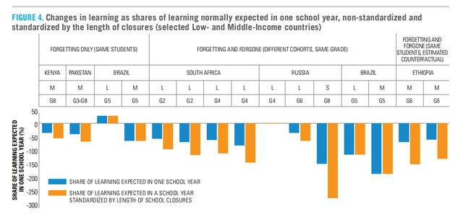

For example, in Sao Paulo, Brazil, the actual math level (dotted orange line) of grade 5 students in 2021 has degenerated to the level 14 years ago, far from the expected level (dotted blue line).

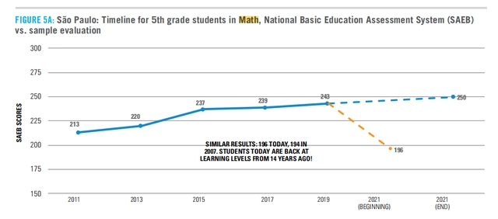

Even in high-income countries that can provide entirely online education, such as the Netherlands, Belgium, the United Kingdom and the United States, there is a similar phenomenon of learning degradation, which is 20% - 120% lower than that in low-income countries. Take the US state of Texas for example. This year, only 30% of the third grade students' math test scores reached the normal level of the grade, lower than 48% in 2019.

Secruity

Millions of children under Covid 19 around the world are at risk of violence, abuse and exploitation. There are several threats to the safety of children, most of which are interrelated.As children drop out of school, communities are closed and the global economic crisis intensifies, families are under extending pressure. Children are victims and witnesses of domestic violence and abuse. Meanwhile, girls are also at risk of dropping out of school, leading to an increase in premature pregnancy. 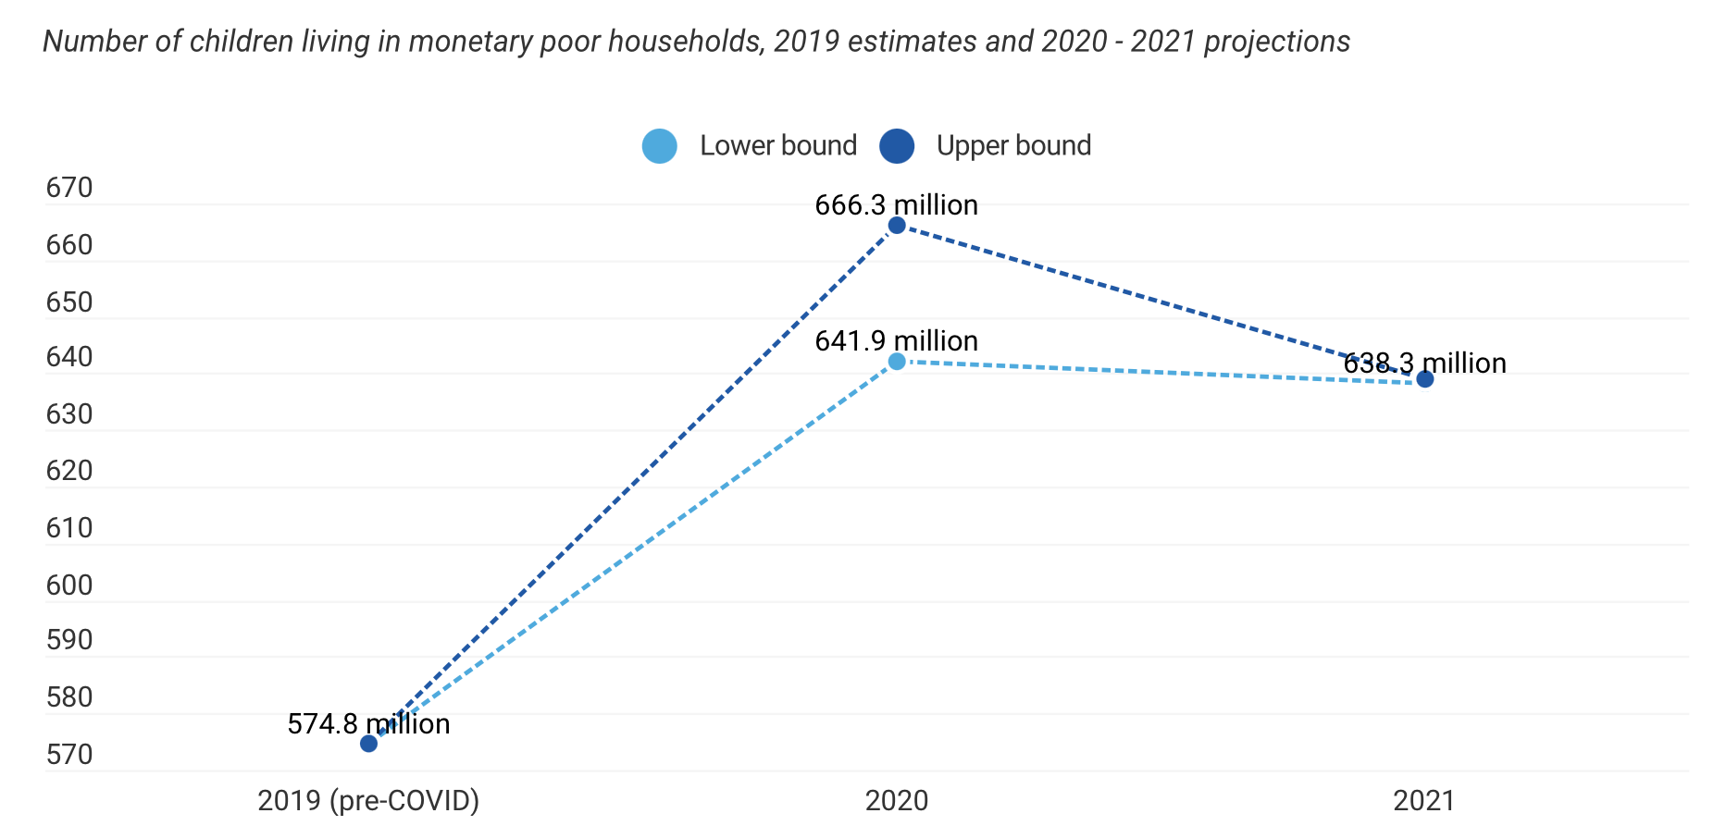

Since children's poverty experience is different from that of adults, it is also important to assess their material defects and potential poverty, and measure their poverty in many ways, not just through income. An additional 60 millions children could be living in montery poor households by the end of 2021, approximately 100 million more children are living in multidimensional poverty-without acess to essential services

Health
Neocoronavirus first invades the respiratory mucosa of children, and in a short time, it will cause children to have high fever, cough, expectoration and other symptoms. If the hyperresponsiveness of the airway causes congestion and oedema of the respiratory mucosa, the airway will evolve narrow, resulting in poor breathing, and even dyspnea, inability to breathe autonomously, asphyxia and other manifestations; Secondly, children infected with the new coronavirus will affect the circulatory system, which may provoke myocardial damage, resulting in children's fatigue, palpitation and shortness of breath, chest pain, and in a short time may cause children's dyspnea. Thirdly, the coronavirus will also have a negative impact on the nervous system of children, which may drive nervous system damage to children in a short time, causing convulsions and other symptoms, and may also cause later intellectual damage.
Reduced household income will force poor families to reduce health and food expenditure, which is particularly vulnerable to children, pregnant women and nursing mothers. As health services are already overwhelmed, sick children are increasingly unable to access medical services. Due to the global economic recession, there will be thousands of new child deaths in 2020, which will reverse the progress made by the international community in reducing infant mortality in the past two to three years.Children account for nearly 50 per cent of the 900 million people living on less than $190 a day. The most predictable outcome of poverty is malnutrition. Even people who can buy enough food may not have access to high-quality, nutritious food for their children. As specific nutrients are necessary to enhance immunity and keep the body strong, malnutrition will inevitably lead to health complications. Unfortunately, children living in extreme poverty often have little or no access to health care.

Tenagers
The general situation in the countries and their localities has affected the daily life of teenagers as 46% report having less motivation to do activities they usually enjoyed. 36% feel less motivated to do regular chores. A study by the International Labour Organization (ILO) found that "the impact of influenza on young people is systematic, profound and disproportionate." Among the 18-24 year olds who worked before the outbreak of influenza, 23% are now unemployed, while working hours and income have decreased. The report added: "The students are pessimistic about their future career prospects. 40% of the students are full of uncertainty and 14% are full of fear.". Globally, young people are more uncertain about the future.

Education

Teenagers’ tertiary education are often affected by the COVID-19 pandemic as well. At Australian universities, about half of international students are still "studying at home", 65% of whom are from China. Even if there are online courses, the quality and outcome of online courses vary by region and age, leading to a decline in students' reading and math abilities, which is roughly proportional to the suspension time. In 2020, the World Bank expects that the global average length of study will be reduced from 7.8 years to 6.9 years. In this case, the average lifetime income of each student will be reduced by 25000 US dollars. With the continuous suspension of classes in many countries, the loss of income will persist to expand. In some countries, the significance of the presence of schools is not only limited to teaching knowledge, but also to providing food, medical services and other safeguards to maintain students' physical and mental health. Nutrition services in schools in low - and middle-income countries have dropped by about 30 per cent, which means that children are more likely to be hungry or malnourished, affecting their long-term development and learning ability. In China, due to the impact of the epidemic, online learning time has grown immensely in the past six months, and the myopia rate of primary and secondary school students has risen by 11.7%.

Between March and April 2020, 59% of prospective international students told QS that the outbreak of COVID-19 did affect their plans to study abroad. In the following month, this proportion rose to 66%, and remained between 65% and 68% in the rest of 2020 and early 2021. From July to August 2021, the proportion of prospective international students who claim that their plans are affected is the highest (71%), while the proportion of students who claim to be uncertain is the lowest (12%). In the past two years, the epidemic has brought about a constantly altering and unpredictable crisis for higher education. The data below reflects that a high proportion of prospective students are constantly adjusting their learning plans to cope with these situations. Since 2020, more than half of international students are more inclined to postpone enrollment or consider changing their study destinations. Thus this makes it more difficult for international students to complete the administrative procedures required for receiving higher education abroad and to study abroad.

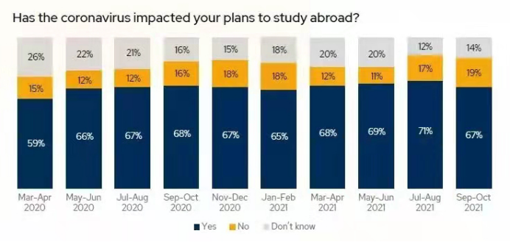

Obtain employment

The epidemic persists to have a consequential impact on the global labour market. The price of food and packaged goods rose by more than 22%. In 2020, the proportion of manufacturing wages and labor costs in total costs will increase from 5% to 20%. The experiences of unemployed young people include low self-esteem, feelings of helplessness and a sense that life may be meaningless. Youth unemployment not only has a negative impact on individuals and families, but also has serious economic and social consequences for the wider community.The recovery will be slow and uncertain, and the imbalance in the employment market increased in terms of regions, income levels, gender, etc. The World Employment and Social Outlook Trends 2022 report foreshadows that compared with the fourth quarter of 2019, the global working hours will be reduced by 52 million full-time jobs. The last full-year estimate in May 2021 estimated that the global working hours would decrease equivalent to 26 million full-time jobs. Although the situation in 2022 is anticipated to be enhanced compared to 2021, the number of global working hours is still inferior to that before the pandemic. At least until 2023, the global unemployment rate will remain higher than the level before the outbreak of COVID-19. The number of unemployed people is estimated to be 207 million in 2022, and 186 million in 2019. The overall impact on employment is far greater than deliberated in these figures because many people have left the workforce. In 2022, the global labour force participation rate is expected to be 1.2 percentage points lower than that in 2019.

The latest forecast reflects, to some extent, the result of the recently mutated coronavirus delta strain and the Omicron strain on the labour market, as well as the significant uncertainty of the future trend of the epidemic. The impact of the crisis on different groups of workers and countries is diverse. These distinctions are deepening inequality within and between countries, weakening the economic, financial and social structures of almost every country, regardless of its development status. This damage may take several years to repair and has potential long-term effects on labour force participation, family income, and social and political cohesion. This result is felt by labour markets in all regions of the world, although substantial distinctions in recovery patterns can be observed. Europe and North America are showing the most optimistic signs of recovery, while Southeast Asia and Latin America and the Caribbean have the most negative prospects. At the national level, the labour market recovery in high-income countries is strongest, while that in low - and middle-income economies is the worst.

The disproportionate impact of the crisis on women's employment is expected to continue in the coming years. The closure of education and training institutions will have a cascading long-term impact on young people, especially those who cannot access the Internet. ILO Director-General Ryder pointed out: "This crisis has lasted for two years, the prospects are fragile, and the road to recovery is lagging and tentative. We have seen the potential lasting damage to the labor market, as well as the boost in poverty and inequality. Many workers are required to move to new areas of work - for example, in order to cope with the long-term downturn in international travel and tourism, many people have to transform careers and engage in other occupations."

Previous Attempts to Resolve the Issue
Many governments at all levels responded to the impact of Covid 19, adopting a local-based approach to policy responses, and implementing national and subnational measures to address the Covid 19 crisis:

- In the area of health, many countries are adopting different territorial approaches, such as policies on masks or blockades.
- In terms of social economy, governments are providing substantial financial support to protect enterprises, families and vulnerable groups. Since March 2020, their global expenditure has exceeded 12 trillion dollars. Many countries and the European Union have reallocated public funds to crisis priorities, supporting health care, small and medium-sized enterprises, vulnerable groups and areas particularly affected by the crisis. In addition, more than two-thirds of OECD countries have adopted measures to support subnational finance in terms of expenditure and income and relaxed fiscal rules.
- Many governments have announced large-scale investment recovery plans focusing on public investment, which are far larger than those adopted in 2008. These investment recovery packages give priority to three areas: strengthening health systems; (ii) digitization; （3） Accelerating the transition to a carbon-neutral economy.

Major Parties Involved

USA
The impact of the new epidemic on the US economy is gradually emerging. The latest figures show that millions of people in the United States are unable to work as a result. Meanwhile, the loss of unemployment income and the boost in medical costs caused by the new epidemic caused serious losses to the American economy. The Brookings Institution, an American think-tank, recently released an analysis report that 2 million to 4 million of the 16 million working-age people affected by the new crown are unable to work. If the median value is taken, it means that 1.8% of the labour force in the United States is incapable to work. David Cutler, a professor of applied economics at Harvard University, reached a similar conclusion with different methods. It is estimated that about 3.5 million Americans are unemployed due to the epidemic. Analysts believe that the absence of millions of workers has exacerbated the shortage of the American labour market, which has been in short supply for more than a year. The analysis of the Brookings Institution shows that the labour shortage is partly due to the epidemic, and its direct and indirect impact on the American economy cannot be underestimated. Caterpillar estimated that if 3.5 million people lost their jobs due to the epidemic, the five-year salary loss caused by the epidemic would be about $1 trillion, or $200 billion annually. In addition to the loss of income, the epidemic has also brought about a decline in the quality of life and an increase in the cost of medical expenditure. The total cost of these three aspects is about 3.7 trillion US dollars. If the cost is allocated to all Americans, each person will bear the cost of 11000 dollars.
Cutler pointed out that it was conservatively estimated that as of late July, at least 9.6 million people were experiencing three or more symptoms related to the new crown. Therefore, the United States urgently needs to formulate policies to deal with it. The spending on relevant testing, treatment and control will bring benefits far higher than the cost to American society. Although the attention of the American people to the epidemic has decreased significantly, and President Biden of the United States has also claimed that the pandemic has ended, the new epidemic in the United States is still fermenting, and the number of infected people continues to rise. This means that the number of people affected by the epidemic continues to increase, and its economic impact will also expand. According to the latest epidemic statistics released by Johns Hopkins University, as of the evening of September 27 local time, the number of new coronal infections in the United States had exceeded 96.16 million. However, the actual number of infections may far exceed the statistics. Ashish Jha, the coordinator of the New Crown Response Working Group of the White House, said at a press conference earlier that the actual number of infections was obviously higher than the statistics because many people were tested at home.

DPRK
According to the DPRK Central News Agency, the North Korean National Emergency Epidemic Prevention Summary Conference was held in Pyongyang on August 10. The highest leader of the DPRK, Kim Jong Un, announced the victory of the largest emergency epidemic prevention war at the meeting. From now on, the largest emergency epidemic prevention system was downgraded to the normal epidemic prevention system. Kim Jong-un said in his speech: China has never had a new vaccine vaccination, but in such a short period of time, it has controlled the aggressive spread of infectious diseases, restored epidemic prevention security, and turned the country back to a virus-free clean area, which is a miracle worthy of special mention in the history of world health. In this fight against the epidemic, North Korea also "integrated traditional Chinese and western medicine" in terms of treatment. Although the so-called modern medical system in North Korea is not as developed as it seems, it has its own traditional Korean medicine (also Chinese medicine in essence). Its traditional Korean medicine accounts for more than 70% of the use in hospitals. The traditional medicines utilised in hospitals include pills, powders, creams, pills and decoction. In addition to Chinese herbal medicine, North Korea also pays special attention to the use of non-drug therapies of traditional medicine in medical units at all levels, such as acupuncture, cupping, massage Finger pressure, etc. That is to say, the victory of the Korean War of Resistance against Epidemics was achieved by early treatment+correct "integrated treatment of traditional Chinese and western medicine". In addition, the socialist system, the role of public hospitals and the close relationship between the military and the people are also important factors in overcoming the epidemic.

United Nations Children’s Fund (UNICEF)
The United Nations Children's Fund (UNICEF) was established on December 11, 1946, with the initial purpose of meeting the urgent needs of children in Europe and China after the Second World War. Since 1950, its work has expanded to meet the long-term needs of children and mothers in all developing countries. In 1953, UNICEF became a permanent member of the United Nations system and was entrusted by the General Assembly of the United Nations to strive for the realization of the rights of mothers, children and children worldwide to survive, develop, be protected and participate. The United Nations Children's Fund said that due to the new epidemic, schools in 23 countries were still partially or completely closed, and 405 million students were still affected by the suspension. Catherine Russell, Executive Director of UNICEF, said that children were "invisible victims of the new epidemic". The United Nations Children's Fund estimates that 147 million children have missed at least half of face-to-face school education. Even if the epidemic situation improves, some vulnerable children, especially girls, have not returned to the reopened schools. UNICEF Executive Director Russell said: "We see that children who used to go to school can read when they returned to school, but now they can't do it. They used to do numbers, but now they can't." But she was most worried about the children who dropped out of school, who might be exploited. She said: "Some children are forced to work because their families are too poor. Girls may also face the tragic fate of early marriage." UNICEF provided vaccines, treatment and diagnosis to millions of children and families affected by the new pneumonia epidemic, UNICEF has supported children around the world to help them recover from the effects of the epidemic by providing vital health, nutrition, education, child protection, water, sanitation and hygiene, gender-based violence and social protection services.

International Labour Orgnization (ILO)
The International Labour Organization was established in 1919 as a subsidiary body of the League of Nations in accordance with the Treaty of Versailles. On December 14, 1946, it became a specialized agency of the United Nations. Its purpose is to promote full employment and improve living standards; Promote cooperation between labour and management; Expand social security measures; Protect workers' life and health. The main activities are: engaging in international labour legislation, formulating conventions and recommendations; Providing assistance and technical cooperation. The highest authority of the organization is the International Labour Conference, which meets once a year.

(World Health Orgnization) WHO
The World Health Organization is a specialized agency under the United Nations. Its headquarters is located in Geneva, Switzerland. Only sovereign countries can participate. It is the largest intergovernmental health organization in the world. The purpose of the World Health Organization is to make people all over the world enjoy the highest possible level of health. The main functions of the World Health Organization include: promoting the prevention and treatment of epidemic and endemic diseases; To provide and enhancing teaching and training in public health, disease treatment and related matters; Promote the determination of international standards for biological products. WHO has been in contact with European policy makers, targeting parents, teachers and school administrators to ensure safe school attendance during the pandemic. The WHO has also been working with countries in the European region of the World Health Organization to minimize interference with children's basic health systems. The Bill and Melinda Gates Foundation has funded a cooperative project with Kazakhstan, Tajikistan and Romania aimed at limiting the indirect impact of the Covid 19 on maternal, newborn, child, adolescent and elderly health services.
报错

Possible Solutions
- Many developing countries were forced to suspend classes. The public services, medical security and economy of countries with weak economies have had a huge impact. The epidemic has also forced the price of food, edible oil and sugar to rise in many developing countries, causing it increasingly difficult for ordinary families to eat enough. In the front of various practical difficulties, rich countries and regions should actively introduce heartwarming measures to help children tide over the epidemic in all aspects. The Child Protection Association could launch publicity activities on social networks to appeal to the whole society to listen to children's needs and let children love reading and learning. We should also improve the ability of parents to help children learn in the epidemic situation. For example, governments can invite experts in relevant fields to hold several lectures and forums online and offline, so that parents can learn how to help children effectively take online lessons. Considering that students in poor countries do not have computers at home and cannot access the Internet, governments should issue mobile phone cards to students on a large scale for free so that they can use mobile data to access the Internet for online learning.
- After the previous rush of online teaching, education administrative departments and schools in various countries have been able to make emergency plans calmly, but problems such as social interruption and psychological anxiety of teachers and students have also emerged. Some teachers did not regard online teaching as a normal trend, as well as did not adjust teaching ideas and improve teaching efficiency in a timely manner, thus still continued the traditional concept of knowledge “score first”. In terms of educational content, online education in many places mainly focuses on general cultural knowledge education in the national curriculum and fails to seize the opportunity to timely educate students on morality and responsibility, scientific knowledge and personal protection, public health knowledge, healthy lifestyle, etc. From the perspective of teaching methods, teachers, students and education administrators still have different degrees of maladjustment to online education, and many teachers' online teaching abilities need to be improved.
- For the employment issue, the state should implement policies and expand employment channels. First, in terms of grass-roots employment, projects such as the "College Students Volunteer Service Western Plan" and "Selected Students", can increase the number of posts, and some posts can reduce the threshold of academic qualifications and expand the employment opportunities for junior college students. It is suggested that the enrollment time of grassroots projects can be advanced to ensure timely participation in campus recruitment in case of failure to enrol. The second is to support more public colleges to expand enrollment plans while expanding the scale of upgrading from junior colleges to undergraduate colleges, to extend the channels for higher vocational students to enter higher education. Third, we should deepen innovation and entrepreneurship and support graduates to start their own businesses. We will continue to promote the construction of college students' entrepreneurship demonstration bases and municipal entrepreneurship incubation bases. Higher vocational colleges will match more special funds to support college students' entrepreneurship, and provide free entrepreneurship venues and perfect entrepreneurship incubation services for students. Every year, graduates will be given one-time subsidies to start businesses, and students will be strongly supported to set up micro-enterprises.
- The state can actively provide psychological guidance to modify the high expectations of job seekers. In view of various psychological problems in the employment process of students, we should find them as soon as possible, strengthen communication and exchange, give professional guidance in a timely manner, and seize the "signs" in a timely manner to help students' physical and mental health. The state should do a solid and in-depth job of guiding students' employment concepts, educating students to prepare more for employment ideologically, helping students to accurately position themselves, constantly updating their employment concepts, adjusting their employment expectations, improving their employment confidence, seizing employment opportunities, and mobilize and encourage graduates to face the basic level of employment. We can also guide graduates to understand the "new business form" and "new pattern", direct them to alter their employment concept and broaden employment channels. It is not only a personal demand but also a social need to establish the concept of employment first and then employment selection.

Bibliography
"UN IANYD Statement on COVID-19 and Youth." new guidance on working with and for young-people during the COVID-19 pandemic. United Nations, 13 Nov. 2009. <https://www.un.org/en/coronavirus/youth>
"UN IANYD Statement on COVID-19 and Youth." new guidance on working with and for young-people during the COVID-19 pandemic. United Nations, 13 Nov. 2009. <https://www.un.org/en/coronavirus/youth>
“COVID-19: talking with teenagers about isolation, quarantine or lockdown” 31 Jan. 2022. <https://raisingchildren.net.au/guides/coronavirus-covid-19-guide/talking-with-teens-lockdown-home-quarantine>
“After dropping in 2020, teen summer employment may be poised to continue its slow comeback” June 7, 2021. <https://www.pewresearch.org/fact-tank/2022/06/21/after-dropping-in-2020-teen-summer-employment-may-be-poised-to-continue-its-slow-comeback/>
“COVID-19 and children” https://data.unicef.org/covid-19-and-children/
“Employment During COVID-19” June 16, 2021. https://youth.gov/youth-topics/employment-during-covid-19
“Monthly unemployment rate among teenagers in the United States from September 2021 to September 2022” Oct 10, 2022. https://www.statista.com/statistics/217429/seasonally-adjusted-monthly-teenage-unemployment-rate-in-the-us/
“COVID-19 and Youth: The Future of Work for Young People” https://www.statista.com/statistics/217429/seasonally-adjusted-monthly-teenage-unemployment-rate-in-the-us/

