Forum: Economics and Social Council
Issue: The question of affordable higher education and addressing the problem of student debt
Student Officer: Yoki Qin
Position: President

Introduction
Higher education, also known as tertiary education, is a critical step toward the nation's development in aspects of social stability and economic improvement. It refers to the third level of education, taking place in universities or further education colleges. Quality and widespread higher education enable educates to enlarge their own knowledge, skills, and accomplishment, and thus receive better employment opportunities. Further, the countries with a considerable rate of higher education have larger production potential as well as lower crime rates. According to the World Bank, the high rate of tertiary education correlate with the household income for each individual, inferring the importance of higher education to improve economic status. However, pursuing higher education can be expensive for both the government and the household due to the lack of qualified educational resources and investments in physical capital. As a result, many less economically developed countries (LEDCs) are unable to provide higher education for their citizens in larger quantities and at lower costs, higher education thus became unaffordable for citizens.
In order to acquire higher education, the low-income household will make loans from the federal government, bank, or credit union to pay for educational purposes. As interests accumulated with the fund of the loan, and also the instability of the value of money, some households are unable to pay back the loan. Hence, the problem of student debt, which is the money that was borrowed but cannot be repaid, become a severe problem around the world.
Constant low rate of higher education and increasing level of student debt is harmful to economic growth and social stability, causing high rate of unemployment, low production potential that corresponds to the nation’s GDP, and a drop in economic well-being. Nations should draft effective and reasonable solutions to solve the problem, either on the scale of the country or the whole world through collaboration.

Definition of Key Terms
Higher education (tertiary education)
Higher education, or tertiary education, refers to the education provided for students who finished secondary education in high school. This education type will give a named degree, diploma, or certificate of higher studies to students at the end of the study program. It usually takes place in universities, further colleges, as well as various types of professional schools in the field of but not limited to law, theology, medicine, education, etc.
Student debt
Student debt, or student loans, refers to the money borrowed by households or individuals to pay for educational purposes, including spending on tuition, books, or living expenses. The repayment of loans includes the money borrowed and the interests incurred in the loan period, which is usually been payback after students graduate or leave the school. There are two types of student debt: federal student debt, referring to the money borrowed from foreign government; private student debt, referring to the money borrowed from a non-federal organization such as banks or credit unions.
Gini Coefficient (Gini Index)
The Gini index represents to what extent the distribution of income among the individuals or households within an economy is different from the perfectly equal distribution. The Gini index varies from 0 to 1, where 0 measures a perfectly equal distribution and 1 measures a perfectly unequal distribution.
Gross Domestic Product (GDP)
Gross Domestic Product (GDP) is an approach to measure the value of the total goods and services produced in an economy during a certain time period. GDP usually represents the sum of consumption by consumers, investments by businesses, government spending, and the net value of exports. GDP is the most commonly used and important indicator of economic status. Besides, GDP per capita is calculated by the total GDP divided by the population of a country.

Background

History of the higher education
Universities remained low until the 18th century in Europe. Before this time, higher education is associated with religious factors and taught by trained clergy, and thus the educational institution was known as monasteries. However, since there was only a small fraction of the population is able to read and write, the monasteries were affordable and accessible for very few citizens.
Around the 13th century, universities evolved from the monasteries, known as the studia generalia. The purpose of the early universities is to educate clerks and monks beyond the level of education in monasteries, and it is the first time the educational institutions admit the involvement of foreign scholars. Those institutions are corporations made up of students and masters; they enjoy independence from the governments but need to finance the capital and daily costs by themselves. By the end of the 18th century, most universities in Europe had developed a unified core curriculum based on 7 areas of knowledge.
Furthermore, in the 19th century, universities in Europe became more common and affordable for their citizens, new subjects and field of study were developed, and they started to accept female students. The most significant change is that higher education institutions were financed by the country’s government, and thus the costs for universities and students decreased. Since then, higher education spread around the world during colonization, and people around the world have an increasing awareness of the importance of higher education.
Theory of student debt
Student debt is a type of loan made from the federal government or other organizations. The low-income households will choose to borrow money in order to pay for tuition or other extra costs, and during the repayment period, the interest will be incurred. Interest refers to the cost of using money, which is a percentage of the principal to be paid per year. When the households repay the loan, they need to repay both the principal and the interest. Hence, if households are unable to repay the debt in a short time period, the interest accumulates and leads to a worse situation for low-income households.
On top of that, students who were dropped from school usually find it harder to repay the loan, resulting from their disadvantage in finding suitable job opportunities and making money.

Covid-19 impacts on economics
Covid-19 is a global pandemic that affects the economy of the whole world negatively. First, the spending on items related to citizens’ health, including vaccines, covid-test, health insurance, and many other kinds of stuff, leads to the budget deficit of several country governments. Budget deficit refers to the situation when government spending is higher than government revenue in a certain time period. This obstructs the government from subsidizing infant or vulnerable industries, and thus lowers the production potential on the macro scale. Second, the strategies to prevent the spread of coronavirus, such as quarantining, disrupt the regular operation of the business.
As figure 1 shows, in the recent two decades, the world GDP fall in recession by two points. One is the economic crisis in 2008, and the other one is the covid-19 pandemic. The world GDP growth was 2.6% in 2019 and was negative 3.3% in 2020. The reduction in GDP represents a decrease in consumption, investment, government spending, and net exports. From the citizens’ points of view, their purchasing power and annual income are decreasing, so pursuing higher education became even harder for the households. As a result, more families choose to make the loan, which is the student debt, but have a lower ability to repay the money, making the circumstance of affordable higher education and student debt worsen.
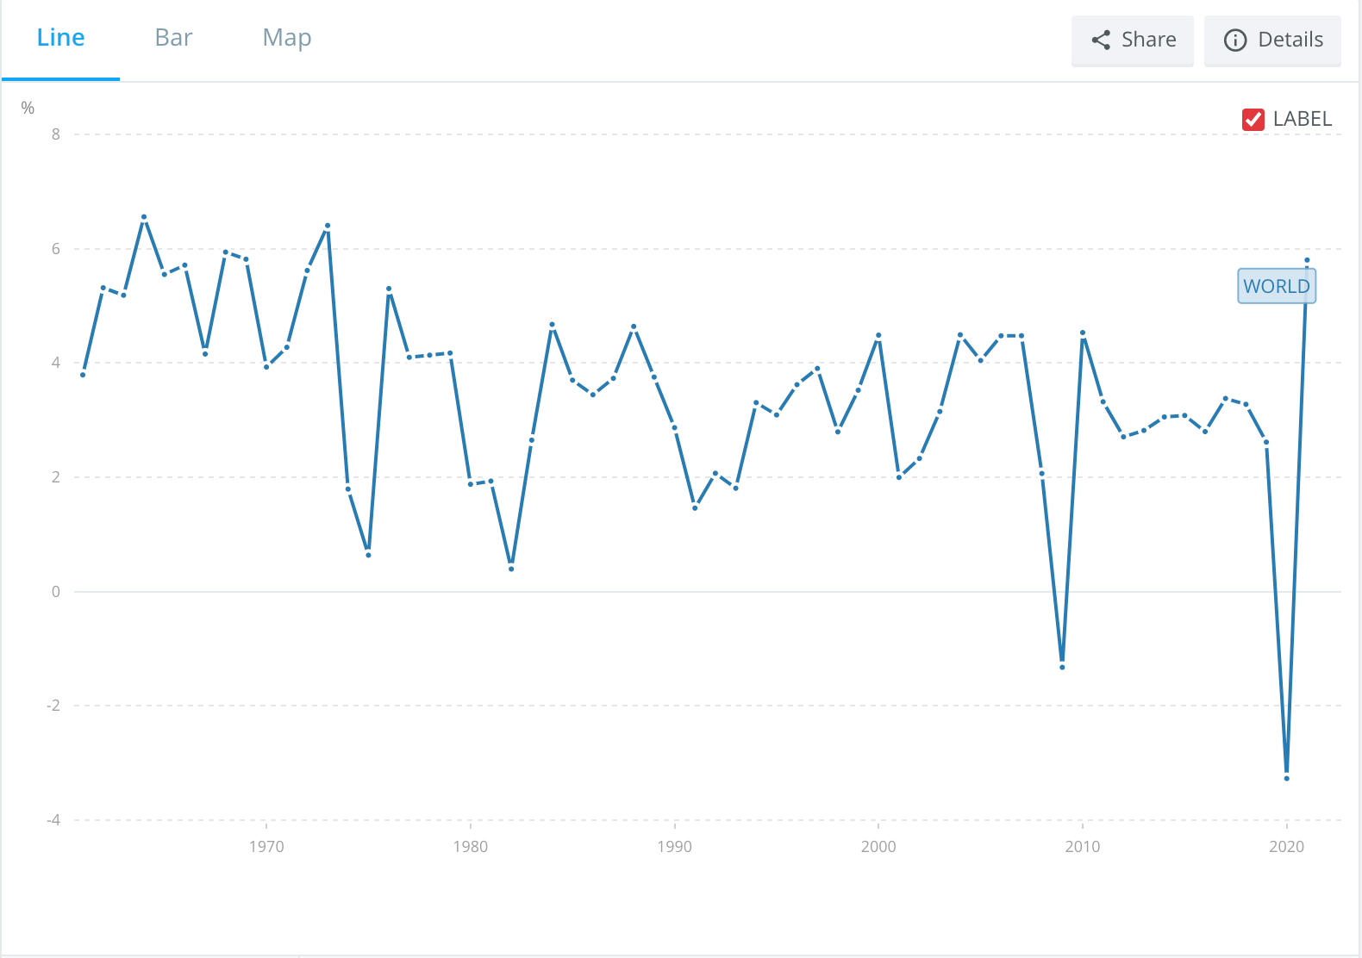
Figure 1. World GDP growth (annual %)

On the other hand, income inequality is also impacted by the covid-19 pandemic. Income inequality is measured by the Gini index, which is considered the percentage of total income held by each 20% of the population, from richest to poorest. The annual global income inequality report calculates the average Gini index of global inequality from 1820 to 2020. As figure 2 shows, in the past two decades, which is 2000 to 2020, the Gini index constantly decreases from 0.72 to 0.67, meaning the global income distribution is closer to the perfectly equal distribution of 0.05. However, the range of decreasing Gini index became lower from 2019 to 2020, inferring a potential impact of the covid-19 pandemic on fixing income inequality.

Income inequality is directly correlated with the various opportunities to receive higher education, especially in the era that in most countries the tuition for higher education isn’t affordable for mid and low-income households. Hence, citizens may fall into a spiral with more student debt in order to pursue affordable higher education, since this is the most effective approach for households to expand the job opportunity in the future. In addition, income inequality also leads to social instability and extreme poverty, as well as challenges to economic growth and economic well-being.

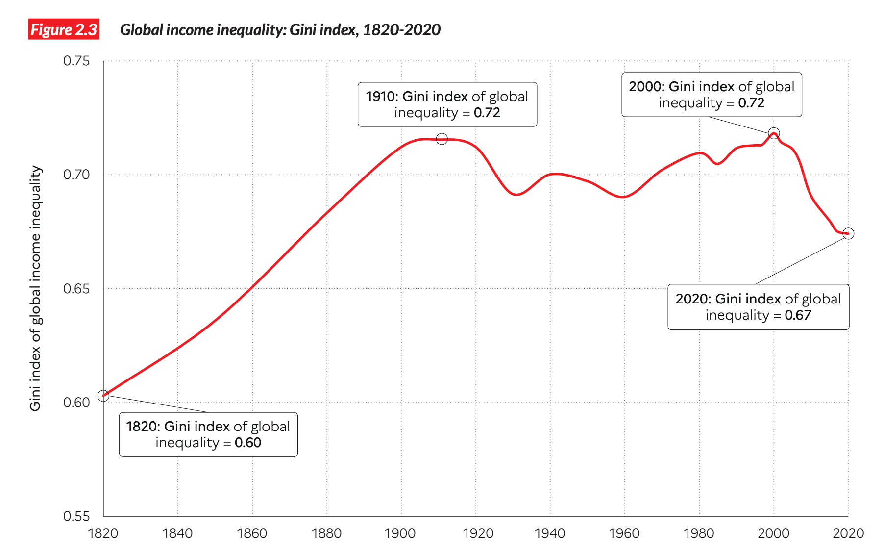

Figure 2. Gini Index of global inequality

Student debt forgiveness

Student debt forgiveness is a policy revised by the government, which suggests the approaches for students to cancel or discharge the loan they need to repay. This policy isn’t universal and doesn’t occur in several nations.

Public Service Loan Forgiveness (PSLF)
Public Service Loan Forgiveness (PSLF) is a type of student debt forgiveness in United States of America. If a citizen is employed by a U.S. federal, state, tribal, local government or not-for-profit organization, it is a chance for him or her to qualified for the PSLF program and receive forgiveness or reduction on its debt. Due to the extended impacts of the covid-19 pandemic on country’s economy, the government has relaxed the restrictions and requirements on acquiring the PSLF service.

Major Parties Involved

The United Nations Educational, Scientific and Cultural Organization (UNESCO)
United Nations Educational, Scientific and Cultural Organization (UNESCO) was established in 1945 and is governed by the General Conference and Executive Board of the United Nations. UNESCO is the only United Nations Organization that is mandated in higher education, and it strives to improve the education system and make quality higher education became more affordable for global citizens. In more detail, UNESCO focuses on “comparative education”, meaning to evaluate the education system of different nations, use the advantages in other education systems to fix the imperfection of a country’s own system, and assist the educational institutions in developing countries or low economic developed countries (LEDCs) to improve the overall quality of the higher education. The action taken by UNESCO that increases the accessibility of higher education lessens the occurrence of student debt as well.

The United States of America (USA)
The United States of America is one of the countries that have the most average student loan debt in the world. By the end of April 2022, there were 19 million students in the US, with average student loan debt of $28400, and the total student debt of all US citizens is significantly higher than in other nations. Concerning the inability of students to repay their loans, the US government proposed a series of policies that may reduce the repayment pressure on the citizens. In the American Presidential Election, Biden promises and now announced a plan that includes loan forgiveness of up to 20000 dollars. This plan provides extensions for student loan repayment pause, and prepares targeted loan relief for low- or mid-income households. The ultimate goal of such policies is to enable society to recover from the covid-19 pandemic and improve higher education accessibility since the average costs of US universities and colleges are constantly increasing.

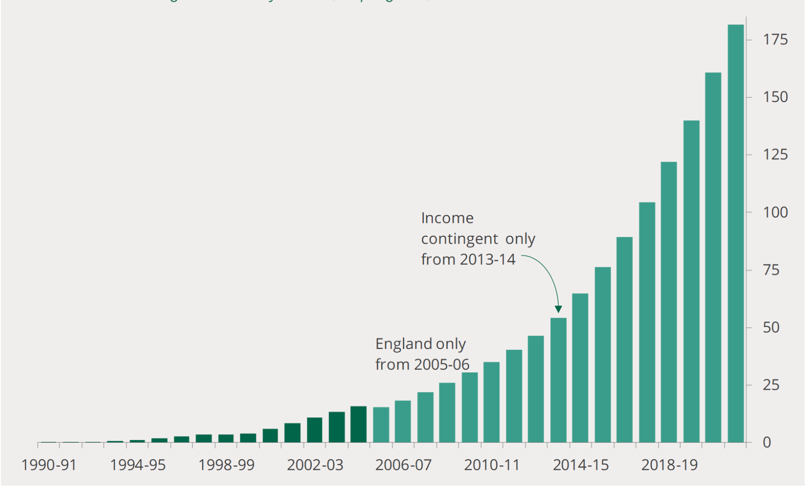
The United Kingdom (UK)

Figure 3. Student debt in the United Kingdom from 1990 to 2022
The United Kingdom (UK) is another country that facing the challenge of increasing student debt. Due to the high inflation and budget deficit of the government, by the end of 16-17, the maintenance grants for students were replaced by loans. And further in 2017, the universities in the UK were admitted to increase the fees and interests of the student debts considering the inflation rate. As a result, the debts that need to be repaid of all UK citizens increases. Figure 3 shows the student debt occurred in the UK from 1990 to 2022, which has reached 182 billion pounds at the end of 2021-2022. In April 2022, the UK government announced the new policy regarding its review on student debt and affordable higher education, in which the government lower the annual salary threshold at which student loans are repaid to £25,000, the repayment term of student debt increases from 30 years to 40 years, and the maximum debt interest rate will be set correspond to the inflation rate. The government expects this policy may increase the repayment rate among low-income households.

Previous Attempts to Resolve the Issue
Affordable higher education directly connects to the sustainable development goals (SDGs) of the United Nations. The third target in Goal 4 of the SDGs “quality education” suggests that “By 2030, ensure equal access for all women and men to affordable and quality technical, vocational and tertiary education, including university.” Hence, there have been several discussions and resolutions by the United Nations toward the problem of affordable higher education and student debt target a particular region or nation. Some of the documents are below:
- World programme for human rights education; September 28, 2022; Document Number: A/HRC/51/L.2
Higher Education Sustainability Initiative (HESI) had several attempts toward such issue. It is a partnership between UN entities and the higher education community. Each year the HESI organizes a global forum to discover the current defect on the global educational system and propose targeted resolution. For instance, the HESI partnership program in 2022 concluded that the action to increase capacity among higher education community should be taken. Through the efforts of such partnership, effective and key challenges can be pointed out, and thus the nations can take action in most effective way. This organization should also be considered during the conference as a useful collaborator to announce the new approaches due to its authority and influence.

Possible Solutions
- Create more job opportunities for the citizens, especially for those who were dropouts from school and didn’t acquire high-skills or professional knowledge. One reason for the inability to repay the student debt is the high unemployment rate. People borrowed money due to the lack of economic condition to pay for the high tuition, but some students are hard to find suitable and high-wage jobs after they graduate, others may even drop out from the school for any reasons. In some conditions, citizens were unable to repay their student debt after decades due to the unemployment. Approaches includes but not limited to the reduction of unemployment benefits and higher minimum wage may encourage the citizens to actively looking for jobs. Besides, the monetary policies, referring to policies that adjust the interest rate of the nation, may also create extra job opportunities for the general public, and thus strengthen their ability to acquire affordable higher education and solve the problem of student debt. However, those suggested approaches are based on the perspective of individual nation, so it may not be completely suitable on the global scale, which should be further discussed and revised.
- Address the problem of inflation. The situation in some nation has reflected that inflation directly leads to the rise in cost of higher education, which further made it non-affordable for more populations, and also increase the pressure of student budget. During the pandemic, the economic is unstable on the global scale, and the global hyperinflation causes the rise in living cost. It is important to lower the inflation rate and stabilize the economy. Additionally, nations’ governments can collaborate with universal non-profit organizations and partnerships such as HESI to effectively employ social welfare for the citizens as a financial support regarding the education, though this may lead to budget deficit for the government itself.
- Urges countries to support the Edu-aid program of international non-profit organization such as UNESCO. NPOs such as UNESCO promote several edu-aids that enable either the higher quality tertiary education in Low-Economic-Developed Countries (LEDCs) or the financial supports for low-income households. However, due to their nature of charity, these programs may not success without the supports of nation’s governments around the world.
- Promote work-study programs for undergraduates and graduate students. Work-study programs give an opportunity for students to acquire tertiary education while they are working, enabling students to earn money to finance their own education. In particular, this type of program may also provide working experiences that are directly relates to students’ coursework. However, this approach may stress the workloads for students, causing potential harmfulness to the quality on output of the tertiary study. As a result, this idea should be further examined.

Bibliography
Correspondent. “Top 8 Ways the Government Helps Students Pursue Education.” The Daily Guardian, 13 Apr. 2022, http://thedailyguardian.com/top-8-ways-the-government-helps-students-pursue-education/
Dabla-Norris, Era, et al. “Causes and Consequences of Income Inequality: A Global Perspective.” Staff Discussion Notes, vol. 15, no. 13, 2015, p. 1, www.imf.org/external/pubs/ft/sdn/2015/sdn1513.pdf, 10.5089/9781513555188.006.
Federal Student Aid. “Public Service Loan Forgiveness.” Federal Student Aid, 26 Dec. 2018, studentaid.gov/manage-loans/forgiveness-cancellation/public-service.
---. “Student Loan Forgiveness.” Federal Student Aid, 18 Sept. 2018, studentaid.gov/manage-loans/forgiveness-cancellation.
---. “The Biden-Harris Administration’s Student Debt Relief Plan Explained.” Studentaid.gov, 2022, studentaid.gov/debt-relief-announcement/.
Higher Education Sustainability Initiative. “Higher Education Sustainability Initiative | Department of Economic and Social Affairs.” Sdgs.un.org, 2022, sdgs.un.org/HESI.
Johnson, Jamie. “Student Debt.” The Balance, 10 Apr. 2022, www.thebalancemoney.com/what-is-student-debt-5196362.
Lewis, Joe, and Paul Bolton. “The Post-18 Education and Funding Review: Government Conclusion.” House of Commons Library, 29 Apr. 2022, researchbriefings.files.parliament.uk/documents/CBP-9348/CBP-9348.pdf. Accessed 5 Oct. 2022.
Mattias Sundholm. “UNESCO: United Nations Educational, Scientific and Cultural Organization - Office of the Secretary-General’s Envoy on Youth.” Office of the Secretary-General’s Envoy on Youth, 23 Aug. 2013, www.un.org/youthenvoy/2013/08/unesco-united-nations-educational-scientific-and-cultural-organization/.
Murthi, Mamta, et al. “Tertiary Education Is Essential for Opportunity, Competitiveness, and Growth.” Blogs.worldbank.org, 12 Oct. 2021, blogs.worldbank.org/education/tertiary-education-essential-opportunity-competitiveness-and-growth.
OECD. “GDP and Spending - Gross Domestic Product (GDP) - OECD Data.” OECD, 2022, data.oecd.org/gdp/gross-domestic-product-gdp.htm.
OECD Statistics Directorate. “OECD Glossary of Statistical Terms - Gini Index Definition.” Oecd.org, 2019, stats.oecd.org/glossary/detail.asp?ID=4842.
Piketty, Thomas, et al. INEQUALITY REPORT 2022. 2022.
Push, Amanda, and Andrew Pentis. “What the U.S. Can Learn from Student Loans in Different Countries | Student Loan Hero.” Student Loan Hero, 15 Aug. 2019, studentloanhero.com/featured/student-loans-different-countries-international/.
Roser, Max, and Esteban Ortiz-Ospina. “Tertiary Education.” Our World in Data, 2015, ourworldindata.org/tertiary-education.
The Editors of Encyclopaedia Britannica. “University - First Universities in the Western Hemisphere.” Encyclopedia Britannica, 11 Apr. 2022, www.britannica.com/topic/university/First-universities-in-the-Western-Hemisphere.
The Editors of Encyclopedia Britannica. “Higher Education.” Encyclopædia Britannica, 3 Mar. 2016, www.britannica.com/topic/higher-education.
The World Bank. “GDP Growth (Annual %) | Data.” Worldbank.org, 2010, data.worldbank.org/indicator/NY.GDP.MKTP.KD.ZG?most_recent_value_desc=true.
United Nations Educational, Scientific and Cultural Organization. “Education Transforms Lives | UNESCO.” Www.unesco.org, 2022, www.unesco.org/en/education.

Appendix or Appendices
- https://studentaid.gov/manage-loans/forgiveness-cancellation (Federal Student Aid)
This website shows several approaches U.S. government provided for its citizens to receive student debt forgiveness. It may inspire the delegates regarding solutions for the problem of high average debt carried by the citizens.

