Forum: First General Assembly
Issue: Promoting gender equality in both domestic and workplace settings
Student Officer: Athena Wang
Position: President

Introduction
Equality is the foundation of peace. To attain a harmonious society, the gap between men and women must be bridged. For centuries, women have been relegated to domestic roles, entrusted with nurturing children and tidying homes, while men were viewed as the sole breadwinners of the family. Not only is this a widely held stereotype, it is also a reality — one that is inseparable from sexual harassment, maltreatment, and the gross violation of human rights.

From being forced into arranged marriages to having their voices silenced, females have generally been viewed as inferior to the opposite sex. These deep-rooted traditions hold immense power, often instilling in women the belief that their future is predetermined. It is, therefore, crucial to provide this demographic with ample opportunities to establish their self-worth.

Discrimination against women is no novel matter. At home, the distribution of household chores and domestic work between husband and wife can be unequal, as gender-defined roles still exist. Social norms construct women as caregivers, but fail to note that their work is, essentially, unpaid care. Those who refuse to conform to these standards grapple with family conflict and, in severe cases, domestic violence. This is particularly prevalent in less economically developed countries (LEDCs), due to deep-rooted patriarchal values.

The workplace is not immune to misogynistic attitudes either. Sexual harassment, unequal pay, and biases in promotion are obstacles that working women face regularly. Although they have been offered a seat at the table, so to speak, managerial positions and roles in the upper echelons of companies are still predominantly occupied by men. On that note, it should be evident that this topic requires collaboration from both genders. Women are not the only victim of sexism; men can also suffer from societal demands, especially in regard to earning a stable income. When members of a community are equal, they work as a cohesive whole, leading to a safer and healthier living environment overall. Reevaluating the roles of men and women, both domestically and economically, is critical for the world to be truly progressive.

Definition of Key Terms

Equality

The state of being equal in status, rights, and opportunities. All individuals are given the same resources, regardless of any individual differences.
Equity

The state of being equal in outcomes, not just in opportunity. Equity recognizes that all individuals come from unique circumstances, and provides the exact resources needed for each person to reach the same goal.
Parity
The state of being equal in pay and position, especially in the workplace.
Unpaid care work

Non-market, unpaid services provided in a household, such as the direct care of persons and the completion of housework.

Background
Gender equality is a fundamental human right, not a privilege. Women are bound by the constraints of society, and the factors acting against them should not be overlooked. While females bear the brunt of gender-based discrimination, the pressure that society places on men is also an area for concern. The First General Assembly ought to resolve this issue by considering and addressing its different dimensions, ultimately adopting a holistic approach to eradicating gender inequality.

Equitable division of domestic matters between partners
Domestic roles are typically gendered, classified as either “men’s work” or “women’s work”. A correlational study conducted on 515 subjects in 2014 revealed that the participating women were significantly more involved than men in seven out of eleven areas of domestic work — shopping for supplies, housekeeping, family management, fetching children to and from school, caring for children, helping them with homework, and engaging with them. The only area in which male involvement outweighed that of females was in house repairs. It can, therefore, be inferred that menial, day-to-day tasks such as cooking and cleaning are viewed as inherently feminine, while those that require manual strength are entrusted to men.

Sadly, these gender roles are often deeply ingrained principles that all individuals are expected to follow. For instance, a survey conducted by the Fawcett Society, a leading charity in the United Kingdom, found that 53% of the women surveyed believed themselves to be personally affected by gender stereotyping in childhood, as it prompted them to take on the caretaker role in their own family. As such, women look after the household on a far more regular basis, which soon becomes problematic once the consequences of unpaid care come into play.

Unpaid care work
Women generally bear the brunt of household chores. While it is indeed the backbone of families and communities, unpaid care is often overlooked in policy agendas, as it is considered a less relevant concern. As stated by the Organization for Economic Co-operation and Development (OECD), social norms view the upkeep of a home as a female prerogative. Regardless of class, wealth, or socioeconomic status, women across the world spend a disproportionate amount of time meeting these expectations. The European Institute for Gender Equality (EIGE) estimates that approximately 91% of mothers spend at least one hour per day on housework, compared to only 30% of fathers.

Additionally, on average, employed women spend 2.3 hours daily on such chores, whereas this figure is 1.6 hours for employed men. In other words, on top of their regular nine-to-five jobs, women allocate an additional portion of their spare time to domestic work, doubling their responsibilities. Although this may be chalked up to the differences in their respective jobs’ shifts and intensity, it is also likely the result of enduring stereotypes — one that leads to an inordinately overworked demographic.

One must not disregard the importance of these women’s time. They walk a fine line between their careers and family, essentially living in an eternal workplace. On one hand, female workers can easily experience burnout from their domestic and career-related duties; on the other, their family’s well-being relies on their undertaking of unpaid care activities. While the men may benefit from this unequal partnership, women suffer from limited opportunities to fully participate in paid activities owing to their lack of time. To illustrate, the International Labor Organization (ILO) claims that women are globally more likely than men to work part-time; specifically, 57% of women constitute all part-time work, with the earnings gap between full-time and part-time jobs being 10%.

Every minute spent on household chores is a minute that could be used to further develop their own marketable skills, pursue additional employment opportunities, and carve a place for themselves. Reconsidering the traditional roles of both men and women in a household is necessary to find a way forward.

Prevention of domestic violence
Gender norms create false expectations, and when these expectations are not met, violence soon ensues. Men holding the stereotype that women are nurturing and submissive typically grow to believe that they “own” their partners; this is especially true if the man is the sole breadwinner in the family. Rigid gender stereotyping, though, leads to punishment against those who do not conform to the image society expects of them. For men, this would be the pressure to possess a domineering, aggressive personality, which forms the basis of toxic masculinity. As for women, they are simply expected to be docile and passive. This drives home the misguided idea that a husband should have control over his wife, including her body.

Domestic violence manifests itself in multiple ways — physical, emotional, psychological, and economic, among others. Individuals from all walks of life are vulnerable to abuse, regardless of their socioeconomic background, education level, or marital status. The UN defines violence against women as “any act of gender-based violence that results in, or is likely to result in, physical, sexual, or mental harm or suffering to women, including threats of such acts, coercion or arbitrary deprivation of liberty, whether occurring in public or in private life”.

Using data collected from 2000 to 2018, spanning 161 different nations, the World Health Organization (WHO) found that 1 in every 3 women worldwide has been sexually harassed by an intimate partner or non-partner in their lifetime. More than 25% of women aged 15-49 years have been subjected to sexual violence, with this percentage rising to 31% and 33% in the African and Eastern Mediterranean regions respectively. Lockdowns from the COVID-19 pandemic have only exacerbated this issue, as some women are consistently exposed to their abusive partners without access to support services for a reprieve.

Progress made in the 20th and 21st centuries
Despite the massive waves of media coverage on this issue in recent years, it was not until 1993 that domestic violence was officially recognized by the UN as an international human rights threat, following the ratification of the Declaration on the Elimination of Violence Against Women (DEVAW).

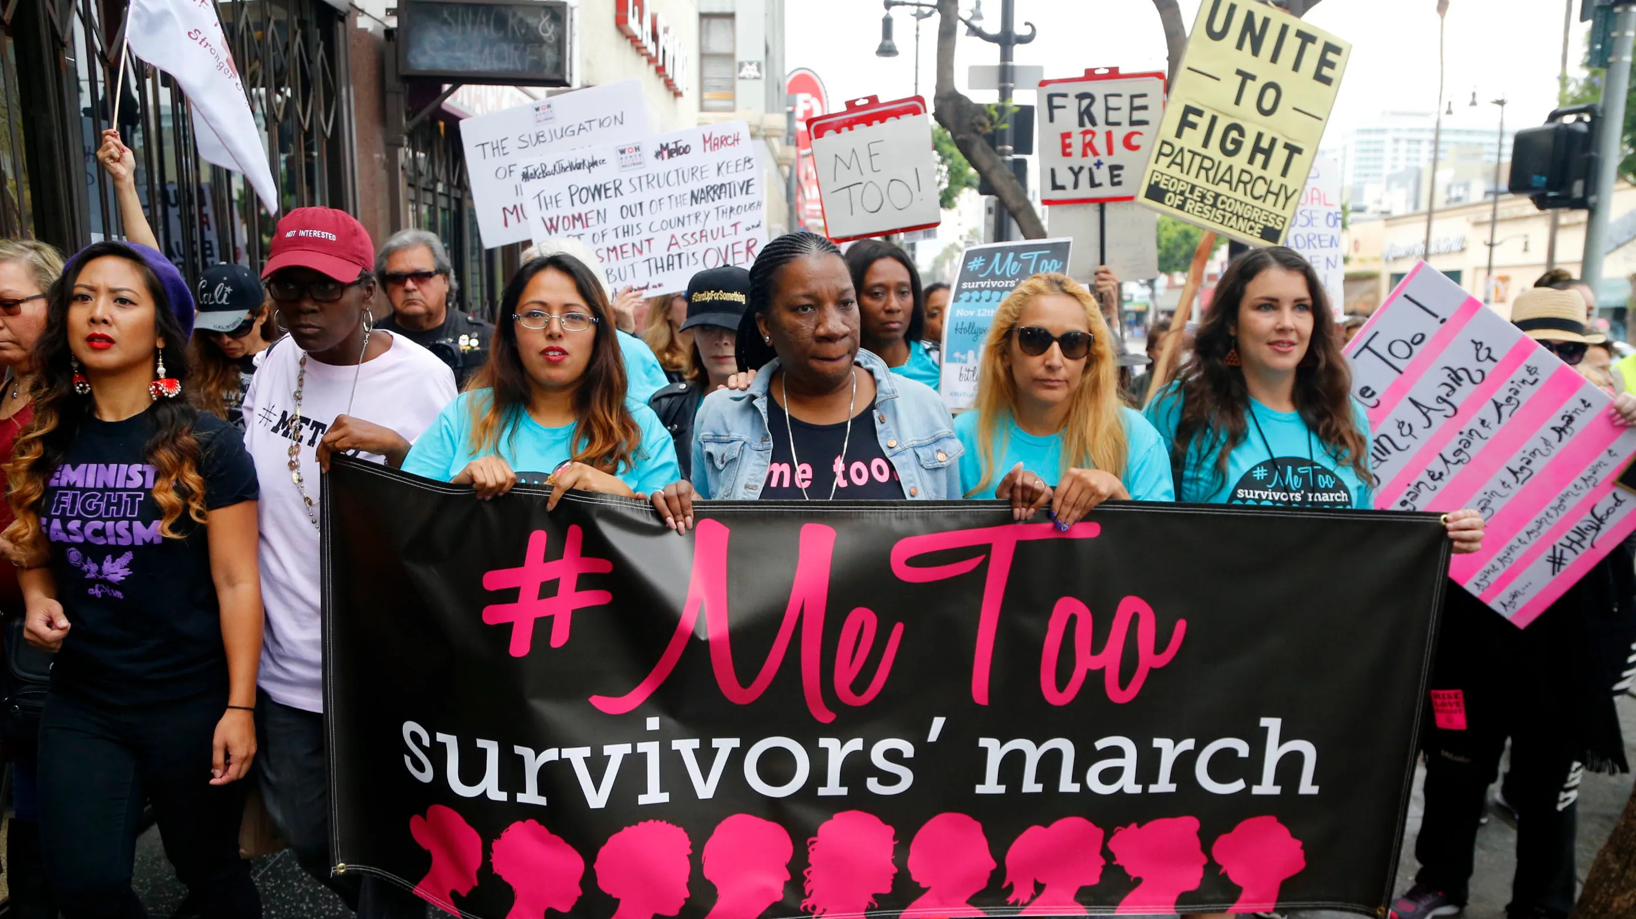
The #MeToo movement of 2017 was also a pivotal event in the journey to curb domestic violence. This viral hashtag was created and spread as a means to support sexual assault victims by showing solidarity. Ever since it took the world by storm, there has been unprecedented momentum in the fight for gender equality.
A 2017 protest in Hollywood against sexual harassment as part of the #MeToo Campaign.

In November 2022, Secretary-General António Guterres called on all governments to “increase funding by 50 percent to women’s rights organizations and movements by 2026”, to “consign violence against women and girls to the history books”. Nevertheless, it remains to be seen whether these proposed actions will pay off, or if more drastic measures must be brought into play.

Gender parity in the workplace
Curbing domestic violence and equally distributing household chores are inarguably critical steps in the right direction, but for gender equality to be maintained in the long term, nations must ensure that women have a firm place in the labor force. Not only should women become financially independent, they should also be afforded the same opportunities as men, without having to grapple with their gender as an obstacle. Only then can parity be attained.

Unequal pay
The ILO estimates that women are, on average, paid 20% less than men employed for the same job. For every dollar earned by a man, his female coworker earns 77 cents. When all other variables are eliminated, it truly comes down to a matter of gender, as well as the stereotypes and responsibilities that accompany each one. In 2018, for instance, the ILO found that women worked on a part-time basis more than men in 68 out of the 73 researched countries; this was presumed to be either the result of unpaid care eating into the time of women, or simply limited opportunities for females to be employed full-time. With the persisting trend, it will take 202 years to close the global gender pay gap if no additional actions are taken.

Climbing the corporate ladder
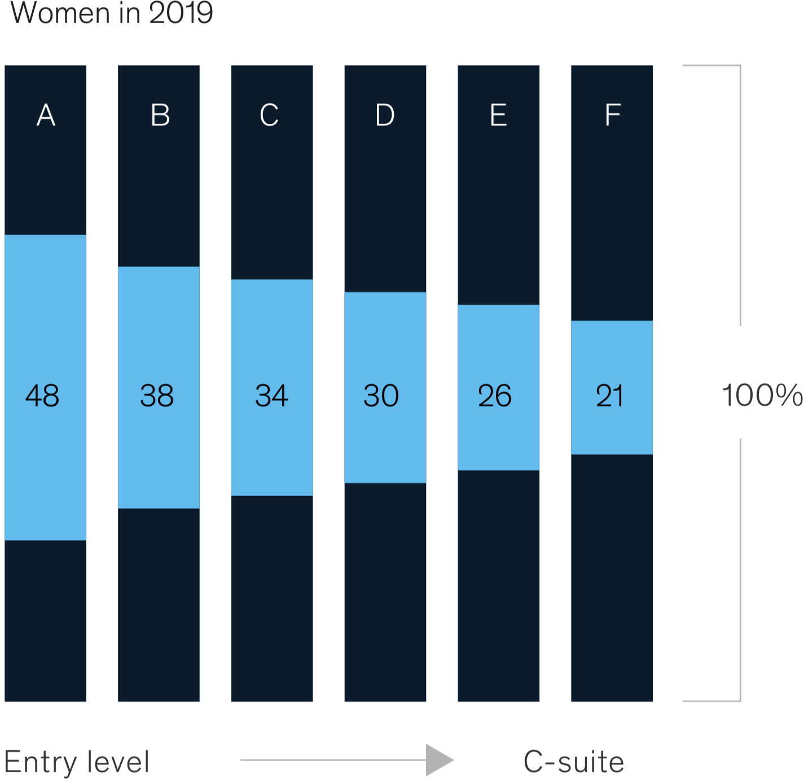
The lack of female representation in the upper echelons of the business world also contributes to this wage gap. The World Economic Forum states that, globally, 37% of leadership positions are filled by women. It should be noted, though, that women’s share of senior roles has seen a global increase steadily since 2017. 2022 saw the highest gender parity score yet. However, the inequitable treatment of women in the workplace still hampers their ability to rise in rank. Nations should still strive to fix the broken rung in the corporate ladder.
McKinsey & Company, a global management consulting firm for leading businesses, states that while women hold 48% of entry-level positions in most industries, every stage of the corporate ladder sees a 4% to 10% reduction, with merely 21% of the executive level being composed of women. The decisions made are, as a result, less representative of female views. Successful workplace policies that promote gender equality are pioneered by male and female employees alike.
Data collected in 2019 by McKinsey & Company showing the reduction of female representation at every stage of the corporate ladder.

Harassment
Both genders can suffer from unsolicited sexual harassment at work, particularly when power dynamics are involved. According to the ILO, 18% of men and women globally have experienced psychological and physical harassment in their working life, with women being especially exposed. However, only one-half of victims worldwide disclosed their experience to those around them, citing “fear for reputation” as the most common explanation. The #MeToo movement, as mentioned previously, has greatly helped to raise awareness of harassment in the workplace, and served as an outlet for silenced victims.

Major Parties Involved

International Labor Organization (ILO)
The mission of the ILO is to advance social and economic justice by promoting social justice and labor rights. It is heavily involved in promoting opportunities for women to “obtain decent work in conditions of freedom, equity, security, and human dignity”. Four key conventions are the Discrimination (Employment and Occupation) Convention (1958), Equal Remuneration Convention (1951), Workers with Family Responsibilities Convention (1981), and the Maternity Protection Convention (2000). Numerous resolutions created by the ILO address pay equity and maternity protection as well. This organization uses a two-pronged approach to achieve gender equality. Firstly, programmes are implemented to systemically address gender-related concerns from women. Secondly, interventions are staged and development efforts are concentrated when need be. The instruments used by the ILO to advocate for gender equality firmly prompt member states to pursue a national policy that includes equality of opportunity in the workplace.

United Nations Entity for Gender Equality and the Empowerment of Women (UN Women)
UN Women was created by the United Nations General Assembly to accelerate the process of attaining gender equality worldwide. It provides grants to support the empowerment of women, through the Fund to End Violence against Women and the Fund for Gender Equality. For instance, UN Women’s WeEmpowerAsia (WEA) programme involves a partnership with the European Union (E.U.) to increase women’s access to business and leadership opportunities in the private sector of the Asia-Pacific region. This has led to increased female participation in the labor force, lessening the disparities between the work of both genders.

United States of America (U.S.)
The U.S. has been a key player in curbing gender inequality, which is evident by its passing of multiple gender-based policies. Following the issuing of the first-ever National Strategy on Gender Equity and Equality in 2021, the nation has pledged to strengthen national policies and work towards eliminating violence against women, while maintaining support services for those affected. Fighting against domestic violence and workplace sexism has become an exceedingly popular sentiment in the United States. The U.S. has voiced support for U.N. initiatives against conflict-related sexual violence as well, allocating more than $2 million to helping victims and raising awareness in 2022. Additionally, the government proposed a bill of $2.6 billion for foreign assistance that involved advancing gender priorities, doubling their contribution from the previous year.

Islamic Republic of Pakistan
Middle Eastern countries such as Pakistan generally have patriarchal societies, and this is reflected in their traditions. The United Nations Children's Fund estimates that 18% of Pakistani women are married during their childhood. This is significant as these girls would likely be raised to be domestic housewives from young, without an opportunity to venture into the job market before marrying their respective husbands. Violence against women is of “significant concern”, according to UN Women; Pakistan is one of the 36 countries yet to criminalize marital rape, the rape of one’s spouse. Although the nation has ratified human rights conventions and drafted legislation such as the National Gender Policy Framework (2022), their actual implementation was considered “weak”.

Previous Attempts to Resolve the Issue

Sustainable Development Goals (SDGs)
In 2015, the United Nations (UN) officially recognized the importance of resolving this issue by adding it to their Sustainable Development Goals — “Goal 5: Achieve gender equality and empower all women and girls.” Together, the 17 Goals were part of the 2030 Agenda for Sustainable Development, which outlined a plan to create an ideal world by 2030. The inclusion of gender equality as one such goal was intended to be a universal call to action; all member states were, therefore, expected to allocate an appropriate amount of time and effort to this objective. Unfortunately, the UN itself has stated that the world is “not on track” to do so by the proposed year, 2030. This is partly due to the standstill brought about by COVID-19, as the progress made in budgeting and pushing policies for gender-responsive programs was pushed behind. Women and girls are still disproportionately affected in terms of unpaid care, domestic violence, and unfair workplace policies. Bold action is required to accelerate this process, including significant monetary investments and the passing of relevant, inclusive laws.

Unconscious bias training
One way in which organizations attempt to eliminate gender-based workplace discrimination is by utilizing unconscious bias training — programs that claim to render individuals aware of their implicit biases. These can include negative stereotypes about women, such as that they do not take their work seriously, or are amenable to being ordered around. Instinctive judgements influence one’s actions. Following the example given above, managers may gravitate to male applicants and be more inclined to hire them because of their subconscious prejudices. This could be a plausible explanation for why women are promoted to fewer managerial positions than men. However, while this training is well-meaning, there is conflicting evidence about its effectiveness. 2020 saw a “distinct trend” of companies shifting away from subconscious bias training, with the United Kingdom’s Civil Service recommending other public-sector organizations to do the same, according to the British Broadcasting Corporation (BBC).

Wage Transparency Act - Germany
In 2017, the Federal Council of Germany passed the “Transparency in Wage Structures Act”: which sought to promote pay parity between both genders. The nation attempted to close its pay gap of 21% — far above the average 16.3% of the European Union — by implementing this law. This act stipulated that all workers at companies with more than 200 employees would be privy to knowledge regarding the median remuneration of the opposite sex, provided that they are in the same, or a comparable, position. However, this value must be derived from the remuneration of six opposite-sex colleagues, which has proved to be a point of contention. The higher up one goes on the corporate ladder, the fewer individuals are available to constitute an appropriately large sample group; as a result, one would not have the right to this information. Unfortunately, as stated previously, gender gaps are most prominent in the upper ranks of companies. Thus, actions should be taken to rectify the oversights of Germany’s Wage Transparency Act.

Equal Pay Law - Iceland
For the past nine years, Iceland has been the highest-ranked country for gender equality. The Act on Equal Status and Equal Rights Irrespective of Gender (2000) was notably successful. In 2021, women held 42% of leadership roles and 40% of parliamentary positions, earning Iceland their reputation as a socially advanced nation. The aforementioned act mandated equal pay for all employees with the same job, thereby preventing gender discrimination from exerting its influence in the workplace. Other member states may consider the case of Iceland when working to eradicate gender inequality.

Possible Solutions

Gender quotas
To close the gender gap, diverse employment is needed in the labor force. In businesses, this can be achieved through the usage of a gender quota, which is an agreed-upon ratio of how many male to female employees ought to be hired. Utilizing this strategy would logically increase the number of working women hired in male-dominated industries and help resolve other issues that come up with employment.
Aside from being associated with unfavorable stereotypes, women also struggle to establish a steady career when they become mothers. A study conducted by Cornell University revealed that, when faced with functionally equivalent applications from women, individuals chose to hire 87% of the women without children and only 47% of those with children. Mothers were theorized to have been held to a higher standard, and thus were not considered “management material”. Meanwhile, the same group of individuals saw fathers as being more committed to their jobs than non-fathers, evincing that it is not simply a matter of being a parent. Though this study was conducted in an artificial setting, these findings have remained true for numerous companies, with the “motherhood penalty” becoming a common phenomenon. A gender quota would, therefore, help level the playing field for women with children.
However, member states should also note that the gender wage gap is largely the result of fewer women being promoted to leadership positions, rather than entry-level ones. Norway first pioneered the idea of applying gender quotas solution to roles higher up on the corporate ladder; in 2008, companies were required to have 40% of board seats occupied by women, lest they face dissolution. Other European countries, such as Belgium, France, and Italy, followed suit during the following years, to varying degrees of success. If a gender quota is used for managerial roles, though, this naturally raises the question of whether it will lead to the employment of unqualified individuals, who are hired not based on merit but simply to satisfy a requirement. In this case, equity triumphs over equality. Nonetheless, it should be acknowledged that gender quotas are, by definition, temporary. They ought to be lifted after they eradicate the build-up of inequality over time.

Reforming workplace policies
Workplace policies should be altered in such a way that they serve all employees. These guidelines set the boundaries for which actions are and are not condoned within the company; as such, they ought to protect the rights of the workforce, especially for members that frequently find themselves victimized.

Harassment
A firm intolerance for sexual harassment in companies must be clearly communicated, to prevent the rights of all employees — females in particular — from being violated. This form of gender inequality has become increasingly prevalent in recent years. From an economic standpoint, not only is the well-being of female employees endangered, the productivity of the perpetrators would be diminished as well, with conducting abusive behavior detracting from their time at work. If policies against harassment are inconsistent among the businesses of a nation, member states may take it upon themselves to curb workplace discrimination by passing legislation, such as the United Kingdom’s Protection from Harassment Act (1997). This would naturally enhance the workplace culture and business environment, in addition to employee commitment and loyalty.

Pay transparency
Similarly, pay transparency is yet another practice that member states can encourage companies to implement. Pay-related information about comparable workers will be voluntarily provided to employees and, in some cases, publicized. This simple tool keeps businesses in check, and incentives them to address the unequal pay between men and women if they wish to remain in the public’s good standing.

Tackling misogynistic social norms
The issue of gender inequality must be nipped in the bud. Violence and biases against women arise from social stigmas; thus, it can be argued that radically changing social norms is the only way to truly solve this issue. “De-feminizing” classic domestic roles and presenting them as what they truly are — tasks to be completed — will remove a prominent barrier that prevents men from fulfilling their caregiving responsibilities.
For instance, the “Africare’s Male Empowerment Project” in Zimbabwe challenges traditional beliefs regarding the role of men in the household, by increasing their involvement in activities typically considered unpaid care work. It defies the constructs of masculinity, and in doing so, balances the power dynamic between man and wife. The participating men later stated that they “started to see [their wives] as a partner, a shareholder in [their] household”, and began “cooking dinner and taking care of [their children]”. It goes without saying that this solution is ideal.
However, changing the rigid gender roles found in domestic settings may be best approached using a grassroots solution — namely, educating the youth. Gender equality education should be covered in childhood, so as to instill in students a healthy attitude towards both men and women from young. Such curriculums would need to address the nature of sexism, as well as the ways in which these norms can be dismantled.
The process of eradicating gender-based discrimination must be taken one step at a time. Changing the minds of others is no small feat. It may span decades, perhaps more, to overturn a notion that has already been entrenched in society. For the sake of gender equality, though, the payoff will be well worth it.

Bibliography
Aloi, Dan. "Mothers Face Disadvantages in Getting Hired, Cornell Study Says." Cornell University, 4 Aug. 2005, news.cornell.edu/stories/2005/08/mothers-face-disadvantages-getting-hired-study-shows . Accessed 11 Jan. 2023.
"Are Gender Quotas Good for Business?" The Economist, 3 Sept. 2018, www.economist.com/the-economist-explains/2018/09/03/are-gender-quotas-good-for-business . Accessed 11 Jan. 2023.
Cerrato, Javier, and Eva Cifre. "Gender Inequality in Household Chores and Work-Family Conflict." Frontiers, 3 Aug. 2018, www.frontiersin.org/articles/10.3389/fpsyg.2018.01330/full#h4 . Accessed 10 Jan. 2023.
"Consign Violence against Women and Girls, 'to the History Books': UN Chief." United Nations - UN News, 23 Nov. 2022, news.un.org/en/story/2022/11/1130957 . Accessed 10 Jan. 2023.
"Driving Women's Entrepreneurship, Innovation, and Leadership in India." UN Women, 2021, asiapacific.unwomen.org/en/digital-library/publications/2021/11/driving-womens-entrepreneurship-innovation-and-leadership-in-india . Accessed 11 Jan. 2023.
"EIGE-2021 Gender Equality Index 2021 Report: Health." European Institute for Gender Equality, eige.europa.eu/publications/gender-equality-index-2021-report/gender-differences-household-chores . Accessed 10 Jan. 2023.
"Facts about Women's Rights in Iceland." The Borgen Project, borgenproject.org/womens-rights-in-iceland/ . Accessed 11 Jan. 2023.
Ferrant, Gaëlle, et al. "Unpaid Care Work: The Missing Link in the Analysis of Gender Gaps in Labour Outcomes." Organisation for Economic Co-operation and Development, Dec. 2014, www.oecd.org/dev/development-gender/Unpaid_care_work.pdf . Accessed 10 Jan. 2023.
"Gender: Equality between Men and Women." International Labor Organization, www.ilo.org/public/english/gender.htm . Accessed 11 Jan. 2023.
"Goal 5: Achieve Gender Equality and Empower All Women and Girls." United Nation, www.un.org/sustainabledevelopment/gender-equality/ . Accessed 10 Jan. 2023.
"How the U.S. Promotes Gender Equality around the World." U.S. Embassy and Consulates in Italy, it.usembassy.gov/how-the-u-s-promotes-gender-equality-around-the-world/ . Accessed 11 Jan. 2023.
Huang, Jess, et al. "Women in the Workplace 2019." McKinsey and Company, Oct. 2019, www.mckinsey.com/~/media/McKinsey/Featured%20Insights/Gender%20Equality/Women%20in%20the%20Workplace%202019/Women-in-the-workplace-2019.pdf . Accessed 10 Jan. 2023.
"In Zimbabwe, Men and Boys Are Involved in Gender Equality." United Nations Africa Renewal, www.un.org/africarenewal/news/zimbabwe-men-and-boys-are-involved-gender-equality . Accessed 11 Jan. 2023.
"The Link between Gender Inequality and Violence against Women." Our Watch, action.ourwatch.org.au/what-is-prevention/the-link-between-gender-inequality-and-violence-against-women/ . Accessed 10 Jan. 2023.
"Recommendations for the United Nations System on Gender Violence and the Workplace." UN Women, 13 Dec. 2011, www.un.org/womenwatch/uncoordination/documents/egm-genderbasedviolence.pdf . Accessed 10 Jan. 2023.
Ro, Christine. "The Complicated Battle over Unconscious-Bias Training." British Broadcasting Corporation (BBC), 29 Mar. 2021, www.bbc.com/worklife/article/20210326-the-complicated-battle-over-unconscious-bias-training . Accessed 11 Jan. 2023.
"2.4 Gender Gaps in Leadership, by Industry and Cohort." World Economic Forum, 13 July 2022, www.weforum.org/reports/global-gender-gap-report-2022/in-full/2-4-gender-gaps-in-leadership-by-industry-and-cohort/ . Accessed 10 Jan. 2023.
"Understanding the Gender Pay Gap." International Labor Organization, 2019, www.ilo.org/wcmsp5/groups/public/---ed_dialogue/---act_emp/documents/publication/wcms_735949.pdf . Accessed 10 Jan. 2023.
"UN Women Pakistan." UN Women, asiapacific.unwomen.org/en/countries/pakistan . Accessed 11 Jan. 2023.
"Violence against Women." World Health Organization, 9 Mar. 2021, www.who.int/news-room/fact-sheets/detail/violence-against-women . Accessed 10 Jan. 2023.
"Violence and Harassment at Work Has Affected More than One in Five People." International Labor Organization, 5 Dec. 2022, www.ilo.org/global/about-the-ilo/newsroom/news/WCMS_863177/lang--en/index.htm . Accessed 10 Jan. 2023.
"What Is Domestic Abuse?" United Nations, www.un.org/en/coronavirus/what-is-domestic-abuse . Accessed 10 Jan. 2023.

