BEIMUN XXXI
Student Officer Handbook

Prepared by the BEIMUN XXXI Secretariat Team
BEIJINGMUN.ORG
Conference Theme: Coexisting Peacefully in a Polarized World
BEIMUN (ISB MUN) Directors:
Courtney Stephens cstephens@isb.bj.edu.cn Amira Sadud Eid asadudeid@isb.bj.edu.cn

BEIMUN Secretariat Team 2023-2024:

Sally Kim, | Co-Secretary-General | sally.kim01@student.isb.bj.edu.cn
George Xu, | Co-Secretary-General | georgeyanyan.xu@student.isb.bj.edu.cn
Edward Zeng, | Deputy Secretary-General | edward.zeng@student.isb.bj.edu.cn
Nan Jiang, | Deputy Secretary-General | nan.jiang@student.isb.bj.edu.cn

Please note that details are subject to change. You may NOT publish this document in any way.
This guide was adapted from the THIMUN Student Booklet.

BEIMUN is a proud member of conferences affiliated with The Hague International Model United Nations (THIMUN).

Table Of Contents
Foreword from the Secretary General (SG) 4
Statement of Purpose 5
Conference Theme 6
Code of Conduct 7
Secretariat & Student Officers 8
Committee Topics 11
Schedule 13
General Reminders 15
Introductory Session 18
General Chair Guidelines 19
Lobbying & Approval Panel 22
Resolution Formatting 25
Resolution Checklist 26
Debate Procedure 28
Points 31
Motions 32
Amendments 34
Crises 36
Chair Scenarios 38
Chairing Stock Phrases 41
Relevant Flow Charts 47
Using Microsoft Teams 52
International Three-Letter Abbreviations 67
BEIMUN Rules of Procedure 73
Appendix 86

Foreword from the SGs
Dear Student Officers,

First of all, congratulations are in order. Thank you for accepting your leadership assignments for the 31st Annual Session of the Beijing Model United Nations (BEIMUN) as a Student Officer.

We hope that the next three days (15th – 17th, March 2024) online with us here at the International School of Beijing (ISB) will be a memorable and fruitful experience for you. As appointed Student Officers, you will have the privilege and the daunting task of facilitating debate and serving delegates in your respective commissions.

Participating in a conference as a Student Officer requires a very different mindset than attending a conference as a delegate. As Student Officers, you will have all gone through the process and experience of being a delegate. Aside from missing out on preparing resolutions and raising placards, you will no longer be “in the scene”.
Instead, you have the power to assist delegates, guide them through diplomatic discussions, and demonstrate impartiality. Being a Student Officer does not mean you are higher in class, rank or position than delegates; it simply means you have been granted a different opportunity.

As a Student Officer, your responsibility is to embody the diplomatic ideals of the United Nations and professional decorum. Once again, practicing humility is of utmost importance. To guide you through this process, this Student Officer Manual will serve as a roadmap to becoming a respectable, successful, and charismatic Student Officer. Do not hesitate to build onto the instructions in this manual and follow your critical and intellectual judgment, as they are your most valuable assets for running a successful commission in Model United Nations.

The BEIMUN Secretariat serves to provide all BEIMUN participants the best MUN experience possible. We are here to help you help delegates have an entertaining and informative experience. Thus, I encourage you to ask questions and seek help along the way throughout your training and during sessions. Whether BEIMUN is your first time being a Student Officer or you are a veteran, the coordinators of BEIMUN cordially welcome all of you and we hope that you make lasting memories at BEIMUN. See you soon.

Sincerely,

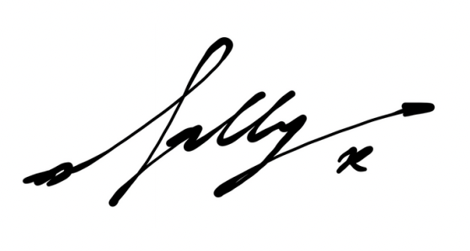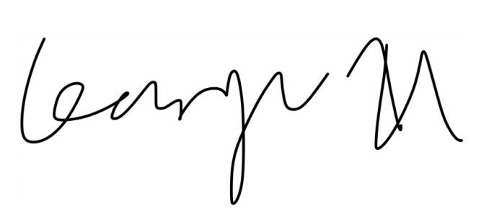

Sally Kim and George Xu
Co-Secretary-Generals
31st Annual Session of BEIMUN

Statement of Purpose
"The Model United Nations program in Beijing is an extension of The Hague International Model United Nations (THIMUN). As an affiliate, BEIMUN seeks to reflect the ideas and principles of a peaceful post-Cold War world. The Coordinators of the program believe that this world order more accurately reflects the original motives of the authors of the 1945 San Francisco Charter than events following the Potsdam Conference of the same year. It is our hope that BEIMUN will continue to act as another regional center of THIMUN conference affiliates helping to revitalize the original ideals of the United Nations.

Current events confirm that the attitudes and voting patterns of the United Nations members are changing. Hence, at BEIMUN, the diplomat of any member state, no matter how large or small, rich or poor, who exercises independence of character and a critical mind, can truly serve his nation honorably in a great experiment in world community. The individual delegate's efforts at communication and behavior will be the most important factors in the drive for a better world and a quality MUN conference. Any delegate who sits idly by weakens his/her own nation's significance in this simulation and therefore the forum as well.

MUN teachers have the daunting instructional task of destroying stereotypes to free students to think and communicate both as delegates and diplomats of a world community. Those with so called non-essential countries, and those with spotlighted countries have equally difficult tasks. Some of you, who view the conference and events on the world stage, think they know the correct position of the spotlighted countries, and that the other countries have little or nothing to contribute. The history of the United Nations in the 1980's, points to the folly of such thinking. This attitude must be overcome if schools are to contribute to establishing the best precedents for future world citizens.

We ask for your understanding, cooperation, and quality work in preparation and participation in order to uphold the principles described above. Victory belongs to all of the delegates at the conference who negotiate the best solutions possible to the most complex issues of this new era in which we live. I do believe that the day is coming when THIMUN and their affiliates become the voice of the youth of this planet and that you, BEIMUN delegates, will have the opportunity to contribute to the shaping of our world."

– Irwin Stein, Founder of BEIMUN, January 1993.

Conference Theme

“Coexisting Peacefully in a Polarized World”
Today, people are entrenched in polarization and hatred, standing on opposite ends of society, and raging against one another. The theme of peaceful coexistence offers a potential solution to this problem. However, many are not cooperating to address this polarization, they make hate speeches, inflammatory comments, and social media posts. Some even worsen the polarization for political purposes and advancement. The privileged, rich, and majority are respected and supported, while the minorities are ignored, discriminated against, and abandoned. It is time for us as a global community, to seek ways to go back to a unified community or something close to that. We must respect each other and embrace different cultures, acknowledging our differences and seeking a peaceful way to coexist in this turbulent world. We can achieve satisfactory coexistence of minorities and the majority only through the collective efforts of human society, while never forgetting the history of marginalization and polarization. By promoting understanding and respect for those with differing opinions, we can create a world in which people of all backgrounds can live together in harmony and find ways to bridge the gaps that divide us. Ultimately, peaceful coexistence requires a willingness to listen, to learn, and to empathize with those around us, even if we disagree with their views. By striving for peaceful coexistence, we can create a world that is more just, more compassionate, and more united.

– BEIMUN XXXI 2024 Secretariat

Code of Conduct
While guests at BEIMUN will merely simulate the roles of representatives of sovereign states and organizations, they are also representatives of their schools and their home countries.

During the conference all participants are expected to exercise a very high standard of personal behavior. This includes maintaining proper formal dress during conference hours and using appropriate parliamentary language while in session. It is also expected that delegates conduct themselves in a professional manner throughout the conference through their language and actions.

The BEIMUN Leadership Team will use a 3-Strike warning policy. Delegates who are caught committing infractions, including not being present in conference sessions, will first receive a warning from their Chair in note form. If the problem persists, Chairs will contact the secretariat to send a warning via email, of which the delegate’s teacher director will be CC’ed. The third infraction will result in an email warning from BEIMUN XXX’s directors, Ms. Sadud and Ms. Stephens, of which the delegate’s teacher director will be CC’ed again and the participation certification may be retracted.

As an online conference, much of the committee work requires the internet and personal devices. Delegates are expected to use the internet in a responsible manner and refrain from social media and sites that do not directly pertain to the debate and topic. Repeated inappropriate use of technology should be reported to the Secretariat and to the BEIMUN Directorate. Further, delegates are required to have cameras on at all times and should be present for all debate and lobbying sessions. Delegates are not permitted to send messages or share files irrelevant to the conference in Teams chats.

Participants are reminded that, though the conference is online, it is hosted in the People’s Republic of China. As such, delegates are expected to respect the host country. Politically sensitive statements and behavior will not be tolerated. Further, regardless of regulations in participants’ own homes, schools, and countries of residence, the use of tobacco, alcohol, and illicit drugs is strictly forbidden during BEIMUN.

Schools should designate at least one director to supervise their students. Each MUN Director is responsible for the care and conduct of her/ his students during conference hours. MUN Directors and chaperones are also expected to adhere to the dress code.

Secretariat & Student Officers

BEIMUN XXXI Secretariat
Co-Secretary-Generals
Sally Kim
George Xu

Deputy Secretary-Generals
Edward Zeng
Nan Jiang

Head Administrative Officers Katherine Wang
Kelly Noh

BEIMUN XXXI Student Officers
General Assembly 1
President
Gabin Kim (Shekou International School) Assistant President
Dana Kim (International School of Beijing) Assistant President
Tracy Chen (Shekou International School)

General Assembly 2
President
David Nam (International School of Beijing)
Assistant President
Elizabeth Van Sluytman (Shekou International School)
Assistant President
Dora Mu (Beijing World Youth Academy)

General Assembly 3
President
Chloe Kim (Seoul Foreign School)
Assistant President
Mi Na Son (International School of Tianjin)
Assistant President
Kanglee Park (International School of Beijing)

Economic and Social Council
President
Kate Han (Seoul Foreign School)
Assistant President
Shian Joo (Shekou International School)
Assistant President
Matthew Kim (International School of Beijing)

Environment Commission
President
A Jin Chang (International School of Tianjin) Assistant President
Isabella Del Rio Garcia (Shekou International School)
Assistant President
Mumu Liu (International School of Beijing)

Human Rights Council
President
Rachael Ho (Dulwich College Beijing)
Assistant President
Jiyoon Ryeom (Saint Paul Academy Daechi)
Assistant President
Luke Brock (International School of Beijing)

World Health Assembly
President
Geon Park (International School of Beijing) Assistant President
Chirag Jadhav (Shekou International School)
Assistant President
Hector He (Shanghai Community International School Pudong Campus)

Disarmament Commission
President
Lucas Duan (International School of Beijing)
Assistant President
Andy Lee (Suzhou Singapore International School)
Assistant President
Lloyd Kim (Dulwich College Beijing)

Security Council
President
Gamin Kim (Shekou International School) Assistant President
Valeriana Lau (International School of Beijing)
Assistant President
Joanie Meng (Beijing World Youth Academy)

Historical Security Council
President
Emma Zhou (Shanghai American School Pudong)
Assistant President
Gordon Zhang (Sha Tin College)
Assistant President
Joshua Ding (International School of Beijing)

Committee Topics

General Assembly (GA)

GA First Committee (GA1)

- Developing a framework for addressing the ethical concerns raised by the use of emerging technologies such as artificial intelligence, biotechnology, and nanotechnology

- Develop strategies to combat recent rise in social, political, and racial polarization in MEDCs

GA Second Committee (GA2)

- Combating discrimination at workplaces and society in LEDCs

- Addressing the impact of the pandemic on education and ensuring equitable access to education in the post-pandemic world

GA Third Committee (GA3)

- Developing policies to address the impact of corruption on global development and promote transparency and accountability in South East Asia

- Examine the role of corporations in promoting or violating human rights and exploring ways to hold corporations accountable for their actions in Africa

Economic and Social Council (ECOSOC)
- Measures to strengthen social safety nets and promote social protection for vulnerable populations, including the elderly and those living in poverty in developing nations

- Developing policies to address the impact of the pandemic on global economic inequality and promote economic recovery and resilience in the African continent

Environment Commission (ENV)
- Addressing the challenges of promoting sustainable fisheries and exploring ways to reduce overfishing and promote sustainable fishing practices especially in African coastal regions

- Examine ways to protect natural resources and promote sustainable development use while simultaneously ensuring the completion of the UN SDG goals by 2030

Human Rights Council (HRC)
- Address challenges faced by people with disabilities, including issues related to accessibility, discrimination, and social exclusion
- Addressing reformation of international policies regarding racism-motivated crimes and terrors given recent rise in hate speech and racially motivated discriminatory policies in MEDCs

World Health Assembly (WHA)
- Developing policies to address the global shortage of medical personnel and improve access to healthcare in low-income countries

- Develop strategies in combatting lack of access to clean water and sanitation in rural and less economically developed areas

Disarmament Commission (DIS)
- Addressing the challenges of regulating and reducing the proliferation of Artificial Intelligence (AI) weapons, including small arms and light weapons

- Develop measures to address growing religious and racial violence on the civilian population sponsored by extremist religious organizations in Afghanistan (ISIS-K)

- Developing a framework to effectively address the post-war decommissioning of weapon systems

Security Council (SC)
- Developing a framework for the addition of new Weapons of Mass Destructions as well as the renewal and expansion of current treaties

- Mitigating the proliferation of totalitarian and religious extremist ideologies within governments

Historical Security Council (HSC)
- Addressing global cooperative efforts in the extermination of the smallpox virus
- Addressing the humanitarian consequences of the Soviet Union’s dissolutio

Schedule
The schedule listed below is according to Beijing time (UTC+8)

Friday, March 15th

Time | Event
8:00 - 8:25 | Welcome & Registration
8:30 - 9:25 | Opening Ceremony
9:35 - 12:00 | Committees in Session
12:00 - 1:00 | Lunch
1:00 - 3:30 | Committees in Session
3:30 - 3:45 | Break
3:45 - 6:00 | Committees in Session / Approval Panel Opens
6:00 - 6:15 | Student Officer Debrief
6:00 | Social Dinner

Saturday, March 16th

Time | Event
8:30 - 10:00 | Committees in Session & Approval Panel Opens
10:00 - 10:15 | Break
10:15 - 12:00 | Committees in Session
12:00 - 12:45 | Lunch
12:45 - 3:30 | Committees in Session
3:30 - 3:40  3:40-4:30  4:30-5:00 | Break  Committees in Session  Student Officer Debrief
Time

Sunday, March 17th

Time | Event
8:30 - 10:00 | Committees in Session
10:00 - 10:15 | Break
10:15 - 12:00 | Committees in Session
12:00 - 1:00 | Lunch
1:00 - 3:30 | Committees in Session
3:30 - 4:15 | Closing Ceremony
4:15 | All participants dismissed

- Student officers of each committee will schedule additional breaks throughout committee secessions determined by the flow of the debate

General Reminders

Dress Code
All participants are expected to adhere to the formal dress code throughout the entirety of the online conference. Participants that are deemed not adhering to the dress code by their student officers, admins, BEIMUN Secretariat or directors will be warned/ penalized in accordance to our Three Strikes policy. Delegates not adhering to the dress code will be asked by their student officer to close their cameras and change to an appropriate attire before returning to the session.
- All participants are expected to dress professionally with respect to a diversity of cultures and identities
- Standard delegate attire for the conference is business jacket, slacks/skirt, and dress shirt/ blouse. Male-identifying delegates must wear ties.
- Dress sweaters, shorts, ball caps, jeans, and sunglasses are considered too casual. Clothes that expose excessive bare skin, reveal undergarments, or are otherwise revealing are inappropriate.
- Dress and skirt should be an appropriate length and not show midriffs or undergarments
- It is not appropriate for delegates to display any national symbols such as flags, pins, crests, etc. on their person during sessions. UN symbols are acceptable.
- Delegates are not allowed to use props at any time during debate when making speeches
- Western business dress is preferred. BEIMUN will not allow any delegate’s attempt to portray a “character” using traditional cultural attire or military uniform as a costume.
- Please see the “BEIMUN Dress Code” document for detailed information.

GA Plenary
There will be no GA plenary in BEIMUN XXX. Instead, there may be a crisis that requires certain committees of the GA to convene.
Social Media and BEIWATCH
BEIWATCH will be providing free online newspapers throughout the conference. They can be accessed on beijingmun.org. Photos and online press pieces will be posted on the ISB MUN Facebook and Instagram pages over the course of the conference. Please consider visiting our social media pages if delegates haven’t done so already. Please use the hashtag #BEIMUN2023 and feel free to share positive reflections via social media.

Oral Report at the Closing Ceremony

Presidents, please remember to prepare and record an oral report of about 2 minutes for your committee. Please report on the result of your debate as well as the issues that were on your agenda. Remember to use that time wisely and address any general remarks you have to the delegates. However, you’ll be cut off if you reach 2 minutes, so please keep your recording within time constraints.

Interacting with Directors, Staff, and Guests
Directors
MUN directors will enter and leave the room at will except when voting procedures commence
and lobby accessibility is limited. Treat them politely and make a good impression. Directors are also reminded not to be interacting with delegates while in session.

Press Staff
When approached by a Press team member, be polite. During the introductory meeting, remember to ask all delegates in the house if they are content with being photographed. Press Team members may ask you for an interview. You are not obligated to accept, so please use your best judgment. They may also ask to interview delegates throughout the debate. This should be approved as long as the Press member and delegate inform you through a note.

Introductory Session
The introductory session is the first stage that occurs. During this time, the chairs will explain general guidelines for delegates regarding conference expectations including rules of procedure, dress code, etc.. Please go over everything on this checklist. There will be no opening speeches for BEIMUN.
- Welcome Delegates

- Student Officer introductions (name, position, school, and introduce yourself)

- Remind delegates of the technology platforms that will be used throughout the conference

- Explain the schedule and what to expect during the next few days (e.g. Lunch dismissals)

- Expectations for delegates

  - Dress Code

  - Minimum participation requirements (1 POI or 1 speech or 1 amendment)

  - Attendance and punctuality (all absences and tardies must be communicated early)

  - Note passing expectations

- BEIMUN Rules of Procedure (Show Powerpoint)

- Explain Lobbying/Merging Procedure & General Committee Rules

  - Role of main submitters and co-submitters

  - Plagiarism will not be tolerated

  - Formatting guidelines & “Expert” chairs

  - Approval Panel availability (see schedule)

- Q&A Session

- Commence lobbying, if time allows (do not start if less than 10 minutes left)

General Chair Guidelines
- Always maintain professionalism and demonstrate high standards of behavior, dress and language:
  - Following the dress code

  - Remaining focused and active during debate

  - Respect all administrative staff, directors, delegates, student officers and guests

  - Punctuality

  - No chewing gum/eating food while speaking

  - No doodling or fiddling during debate

  - Refraining from phone usage unless it’s an emergency

  - Being a role model for the delegates

  - Avoiding the usage of slang (e.g “Guys“ and “Dude“)

  - Staying on task

- Speak loudly and clearly, so delegates in the committee can hear you at all times

- Explain each stage of THIMUN procedure to ensure there is no confusion

- Follow the procedures strictly, but be flexible with different situations. Some examples include:

  - When delegates use personal pronouns during debate, an occasional reminder directed towards the house is enough. Do not remind the speaker every time they make a mistake.

  - When delegates make a procedural error, it is the job of the chair to correct this error on the spot. (e.g. motion to move into voting procedure is not a valid motion).

  - If delegates are not using parliamentary language, intervene immediately.

- Provide a rationale for all of your decisions

- Pay attention to debate and ensure you are aware of what is going on at all times

- Maintain your authority by:

  - Not being afraid to admit your mistakes (e.g “The Chair stands corrected” is enough - just move on)

  - Keeping calm. Never yell at your delegates or respond in an aggressive manner

  - Always asking the house to wait for a short moment in order for you to look up proper procedure in the Student Officer Manual if you are ever in doubt

  - Being consistent in your chairing

  - Being firm but not overbearing

  - Remembering the rules of procedure and being knowledgeable about your topic.

- Communication

  - Plan your day with your co-chairs

  - Decide who will be chairing which resolution

  - Do not disagree with your co-chairs in front of your committee. Resolve situations calmly

  - Have only one chair chairing at a time. Don’t interrupt each other. If you are going to switch chairs, ensure that you properly yield your chairing rights

  - If you’re not sure about making a decision, ask your co-chairs or address concerns to the secretariat

- Time management

  - Set debate time for resolutions in the beginning. Ensure that strong resolutions will have enough time to be debated. A suggestion would be to limit the number of resolutions while delegates are still in the merging process

  - Use a stopwatch to monitor the speaking time and try to be strict about timing. If a delegate goes over the time limit, don’t be afraid to cut them off

  - Limit the number of breaks. Make sure to state whether the breaks will be on or offline

- Organisation

  - Have everything you need on the table (e.g notepaper, pens, laptops, timers, resolutions to be debated etc.) and remove anything you don’t need

  - Make sure to update the participation tally sheet as delegates speak

  - Go to the bathroom beforehand - don’t get up unless it is urgent

- When you are not chairing, stay active by:

  - Managing the amendments and prioritizing them based on constructiveness (the expert chair on the topic being debated should always handle amendments)

  - Keeping track of both diplomatic and disruptive delegates so the other chairs can pick delegates who will contribute to debate

  - Responding to notes. Remember to send notes to delegates who have not spoken and encourage them to speak

- Being approachable and helpful

  - Remember to ask for questions during lobbying

  - Approach the delegates during lobbying and check in on their progress. Try to be engaged by offering ideas, but don’t impose your opinions on the delegates

  - Be knowledgeable about the topic and MUN in general. Never be condescending.

Lobbying & Approval Panel
Lobbying is the time where delegates will merge their draft resolutions/clauses. It should be a focused and productive working time for both delegates and chairs. Lobbying usually will take place during the first day. However, if the president feels that the committee is no longer productive, they may choose to begin debate early with permission from the executives. For instructions on how to implement the general lobbying framework online, see the rest of the guide.
Expectations for Chairs Merging Stage
Before lobbying begins, please remind delegates who the expert chair on each topic is. Go
through the resolution process, the consequences of plagiarism, etc. Before any resolutions are sent for the chairs’ approval, chairs should remain actively engaged during the lobbying by:
- Dividing and merging delegates into resolution groups and ensuring there are a good number of resolutions to be debated (ideally two per topic)

- Helping delegates join different resolution groups to ensure they are fully engaged

- Checking on delegates to ensure they are making good progress and reminding them about timing

- Mediating between delegates who may not wish to merge resolutions

- Offering expertise and guidance on their expert topic(s)

- Ensuring any updates and reminders are announced promptly to the delegates

- Answering any questions delegates may have during lobbying

- Ensuring Delegates are aware of the resolution process

Please ensure that there is always one chair at the general committee channel. Don’t be afraid to be too engaged with the delegates - help them in anyway possible.
Approval Stage

When the delegates are ready with their final resolution, a Chair must approve it. During this stage the chair must carefully check over the resolution for the following:
  - Any signs of possible plagiarism

  - Alignment with the principles of the UN Charter

  - Inappropriate material

  - Obvious grammatical errors

  - Operative phrases that are used only for the Security Council

  - Possible ways of improving the clause

  - Formatting the resolution (see the “Resolution” section of this guide)

  - Anything else that the chair deems necessary

Chairs should read the resolution fully before sending it to the Approval Panel. The Approval Panel will mainly check for formatting errors, thus if there are any major mistakes the chairs overlook, they may not be able to be fixed in time for debate.
After you have approved the resolution:

- Download a copy from Word Online to your computer

- Rename the file as follows: Committee_FullTopic_R#. For example, GA1_Measures to inhibit cross-border money laundering_R1
- Upload it to the Approval Panel OneDrive. The link will be shared to your email closer to the conference.

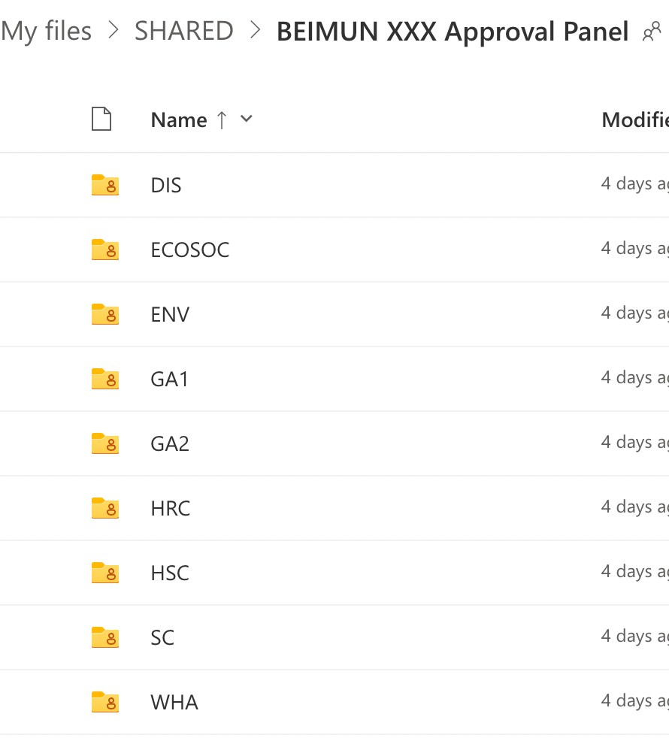
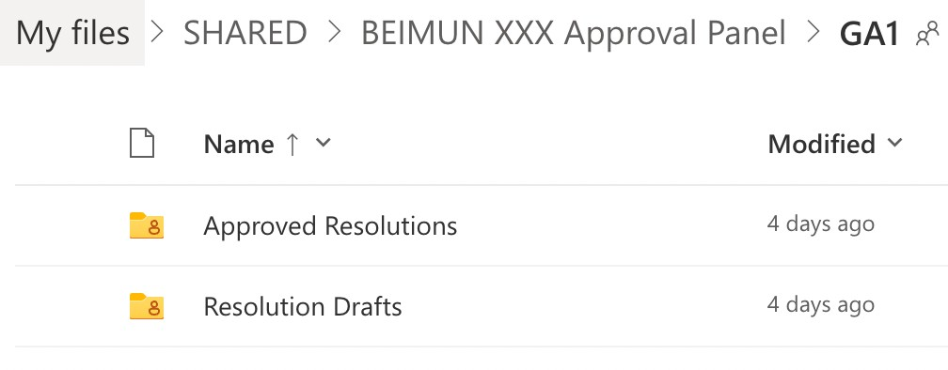
  - Click on the OneDrive link. Click on your committee’s folder.
  - Click on the “Resolution Drafts” folder.

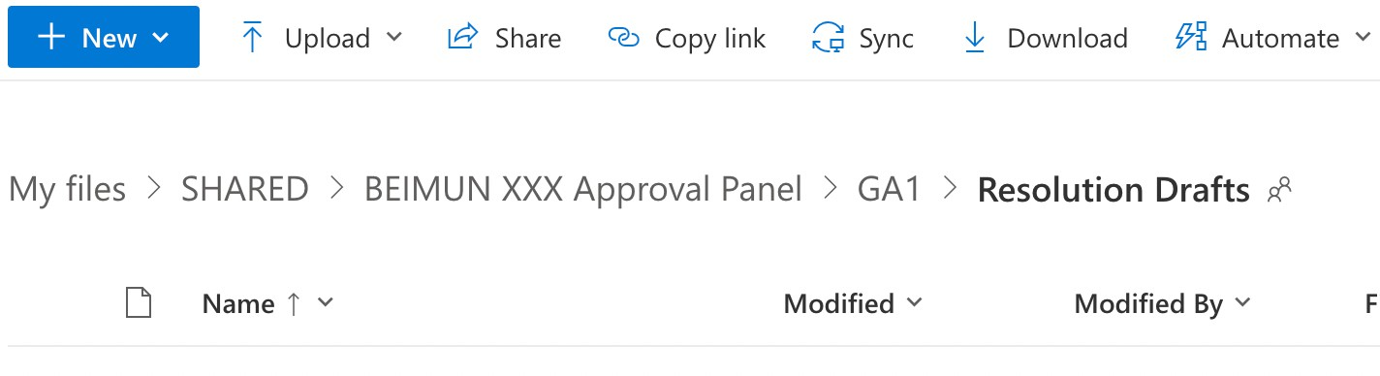
  - Click the blue “New” button and upload the resolution from your computer.

- Send the resolution file’s name to the main submitter.

- Send the main submitter to the Approval Panel General channel on Teams.

Resolution Formatting
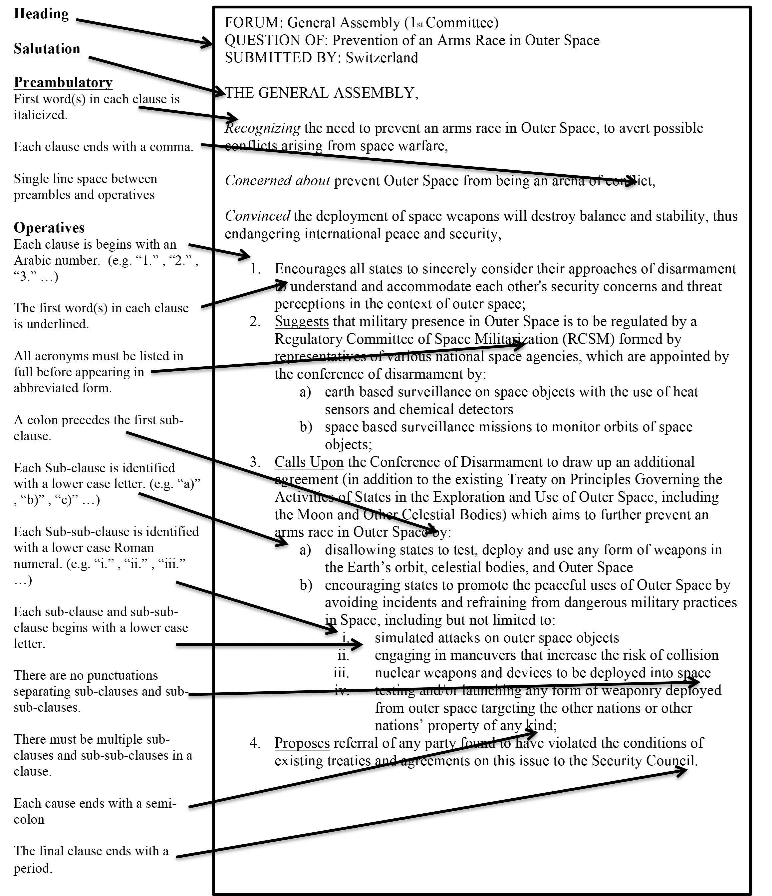

Resolution Checklist
- Times New Roman, Size 12
- Heading in bolded capital letters: FORUM:, QUESTION OF:, SUBMITTED BY:
- A Line Space placed between the Heading and the Salutation
- The name of the Forum, typed in capital letters. e.g THE GENERAL ASSEMBLY,

Pre-ambulatory Clauses:
- All clauses state facts that outline the problem at hand and express urgency in resolving it.
- A comma separates each clause.
- All clauses begin with a pre-ambulatory verb or adjective that is italicized.
- All Acronyms must appear in full before in abbreviated form

Operative Clauses:
- All clauses suggest ways to solve the problem at hand, instead of stating facts
- Numbered with Arabic numerals. (e.g. “1.” , “2.” , “3.” ...)
- Begins with an Operative Verb that is underlined (Refer to next page for a list)
- All Acronyms must appear in full before in abbreviated form
- A colon precedes the first Sub-clause or the first sub-sub-clause
- Sub-clause is identified with a lower case letter. (e.g. “a)” , “b)” , “c)” ...)
- Sub-sub-clause is identified with a lower case Roman numeral. (e.g. “i.” , “ii.” , “iii.” ...)
- Each Sub-clause and sub-sub-clause begins with a lower case letter.
- There must be multiple Sub-clauses
- There are no punctuations separating sub-clauses/ sub-sub-clauses
- Each operative clause ends with a semi-colon.
- The final operative clause ends with a period.

Pre-ambulatory Verbs and Adjectives

Acknowledging Affirming Alarmed by Approving Aware of Bearing in mind Believing Concerned Confident Conscious Contemplating Convinced Declaring Deploring Desiring Disturbed Emphasizing
Expecting
Expressing its appreciation Expressing its satisfaction Fulfilling
Fully alarmed Fully aware Fully believing Guided by Having adopted
Having considered Having considered further Having devoted attention Having examined
Having heard Having received Having studied Keeping in mind
Noting further Noting with approval
Noting with deep concern Noting with regret Noting with satisfaction Observing
Reaffirming Realizing Recalling Recognizing Referring Regretting Seeking
Taking into account Taking into consideration Taking note
Viewing with appreciation Welcoming

* You can add emphasis by adding modifiers such as “Fully”, “Further”, “Deeply” etc. Aware becomes Fully aware
Recalling becomes Further recalling Regretting becomes Deeply regretting

Operative Verbs

Accepts Affirms Approves Asks Authorizes Calls
Calls upon Condemns Confirms Congratulates Considers Decides
Declares accordingly Demands
Deplores Designates
Draws the attention Emphasizes Encourages
Endorses
Expresses its appreciation Expresses its hope
Hopes Invites Notes Proclaims Reaffirms
Recommends
Regrets Reminds Requests Resolves Sanctions
Solemnly affirms Supports
Takes note of Transmits Trusts
Urges Wishes

- You can add emphasis by adding modifiers such as “Fully”, “Further”, “Deeply” etc. Requests becomes Strongly requests
Urges becomes Strongly urges

- Bolded Phrases for Security Council only

Debate Procedure
The debate procedure of BEIMUN will follow THIMUN Rules of procedure, with the exception that follow ups will be allowed.

General Expectations for Delegates:
- Delegates need to speak in third person.
- Delegates must wait till the Chair has finished speaking to raise their hands on Teams
- Male delegates must wear jackets when they are speaking
- Delegates must respect all members of the house including student officers, other delegates, administrative staff, guest and directors
- No direct dialogue between delegates is permitted
- Delegates should refer to Less Economically Developed countries as LEDCs, not “Third World“
- Delegates should refer to sub-sub clauses as sub-sub clause “One“ instead of reading out the roman numeral of “i”
- Delegates are not allowed to make up facts on the spot
- All dress code must be followed
- Any inappropriate behaviors such as singing, informal jokes, clowning around, etc. should be deemed out of order immediately and brought to the attention of the executive council if the problem persists.
- Delegates must have cameras on at all times and be muted when they are not speaking

Note-Passing
- Note passing is allowed between delegates, as long as the message pertains to the debate
- Notes can only be written in English
- All notes passed by delegates must be screened by admins unless they are directed towards student officers
- Administrative staff will not screen the notes to/by student officers

- Remind delegates that note passing is a privilege and that any inappropriate notes will be deleted
- If the house is out of order, please make the executive team aware of the situation before suspending note-passing

Roll Call
Roll call must be taken every time the committee assembles before debate (e.g morning and after lunch). Please remind delegates to state “Present and Voting”. Late delegates must be reminded to send a note to the chair in order for their attendance to be changed. If there are any delegates who are consistently absent please pass their delegations onto the executive council. At the end of Roll Call, ask to see if there are any delegations who have not been called, make sure to make appropriate changes to
the attendance sheet. A session may begin if there is one third of the delegates present.

Open Debate vs Closed Debate
Open debate is the main debate time on the resolution in which delegates may: Make speeches, make amendments etc. Closed debate time is a timeframe in which the topic of debate is limited to amendments or a specific clause (in SC, HSC).

Debate Time
Debate time usually set for somewhere between 1 hour and 1 hour 30 minutes per resolution, however student officers must ensure that debate time is balanced for all resolutions. The allocated debate time should be announced after the reading of the operative clauses by the

main submitter. If there is a need to adjourn debate, always state the time delegates need to return by instead of stating the length the session will be adjourned by. For lunch always subtract 10 minutes for the returning time as delegates will usually take 5-10 minutes to settle down.

Yielding
The floor may be yielded by one delegate to another only once consecutively, meaning if A yields to B, B cannot yield to C. Chairs may ask delegates to yield the floor back whenever it is necessary.

Speaking Tallying
To ensure all delegates are engaged, Chairs are required to keep a speaking tally on all delegates and call upon those delegates that have had fewer opportunities to speak. Delegates will be considered absent and have their participation certification removed if they are consistently silent and have their cameras off. The speaking tallying table may be accessed on AirTable.

Points
Points cannot be directly stated by delegates until the chair has stated “Delegate please unmute and state your point“. The only point that is allowed to interrupt a speaker is a point of personal privilege due to audibility.

Point of Personal Privilege
Refers to the well-being of delegates. An example is audibility (if the delegate speaking cannot be heard)

Point of Order
Refers to procedural matters. An example is if the chair makes a mistake in debate procedure.

Point of Information to the Speaker
A question directed towards the delegate speaking. is point must be recognized by the Chair, and must be stated in a question form. Please ensure there are no dialogue between delegates during the process of asking points of information

Follow-up: a clarification question to the original question, is allowed at BEIMUN, however the follow- up must pertain to the previous question.

Point of Information to the Chair
A question directed towards the chairs that can refer to any type of issue.

Point of Parliamentary Enquiry
A question directed towards the chairs pertaining to Rules of Procedure. An example may be “Could the chair please clarify what is an amendment to the second degree?”

Order of the Day
Not commonly used, but called by a delegate to return to the main agenda of the forum if they feel the debate has drifted from the original agenda.

Motions
When delegates state motions the chair must ensure to ask for seconds and objections (with the exception of Motion to Divide the House). Sometimes a vote must be taken in which abstentions are not allowed, in order to see if a motion passes. However, chairs have the right to overrule any motions. All motions should not interrupt a speaker.

Motion to Move to Previous Question
Calls for the house to proceed to the next section of debate. (e.g from time in favor to time against, from time against to voting procedure). is motion can be stopped by an objection and does not require a vote. Chairs are not encouraged to entertain this motion for a full resolution, unless the debate is completely exhausted.

Motion to Adjourn the Debate/Motion to Table the Resolution
Calls for the house to temporary dispose a resolution until the committee has finished all other resolutions. Not an encouraged motion, please do not introduce this motion to the house as usually the resolutions that have been tabled will not get debated at the end. However, in the case the motion is moved, please attempt to overrule it. If it does come down to moving this motion, please entertain the submitter of the motion on why it is necessary to table this resolution, and then entertain one speaker in favor and one speaker against this motion. en the forum will put this motion to a vote, if the motion passes, resolution on this debate will stop, however if it fails, debate will continue.

Motion to Reconsider a Resolution
Can only be moved at the end of the forum’s agenda, where is calls for a re-vote or re-debate of a resolution that had already been voted on. Requires to be voted on and 2/3 majority to pass.

Motion to Refer a Resolution to Another Forum
Moves a resolution to another forum. Again a discouraged motion, as other forums have their own resolutions to debate. Please encourage the amending of clauses in the resolution in order to avoid referring it to another forum. Requires to be voted on by house.

Motion to Divide the House
Made after vote where the total number of abstentions may change the result of the vote, which calls for a roll call vote where delegates may vote in favor, against or abstain. Does not require a second or a vote and cannot be stopped by an objection, it is entertained at the discretion of the Chair. (If the resolution already passes, please do not entertain this motion as we are trying to be constructive).

Motion to Appeal the Decision of the Chair
Do not introduce this motion to your house as it will become hectic. It is motion made directly after a chairs decision in order to appeal the decision in question. Chair must clearly explain the reasoning behind their decision, while delegates do not have the right to explain the motion. Requires 2/3 majority to pass. Can only overrule the decision of the chair, not result in the removal of the Chair.

Motion to Withdraw a Resolution
Can be done at any time before voting has started, on the condition that all submitters including co- submitters agree.

Motion to Extend Debate Time
Is a motion asking for more time on debating the resolution. Requires a second to be moved, cannot be stopped by an objection as it is at the discretion of the chair. Requires a vote in order to be entertained.

Motion to Extend Points of Information
Or it can be addressed through a point of information to the chair. Can be entertained at the discretion of the chair. Does not require a second, or an objection, however requires the consent of the speaker.

Any other motions or points that raised can be considered to be invalid. However, if delegates state the wrong wording (e.g “Motion to move to previous question” to “Motion to move to voting procedure”) please ensure the are corrected and the motion is still moved.

Amendments
Amendments may be moved by delegates if they indicate to the chair that they have submitted an amendment once they are recognized to speak. No chair should ever move an amendment. Once the amendment is moved, the chair must read out the amendment and display it to the house via screen- sharing.

Format of Amendments
- Indicate the submitter of the amendment
- Select one of: Add, Strike, Amend
- Should only change one clause (e.g cannot be strike out clause 2 and 3)
- If you approve an amendment, send a note to the delegate informing them
- If you reject an amendment, send a note to the delegate explaining why

–––––––––––––––––––––––––––– BEIMUN XXX –––––––––––––––––––––––––––

Amendment Process
- Delegate moves the amendment.
- Chair reads out amendment, sets closed debate time.
- Submitter makes a speech on the amendment during time in favor. If time left, chair may recognized more speakers in favor
- Time against amendment, during which delegates may submit amendment to the second degree
- Voting on the amendment, Delegates may vote in favor, against or abstain (abstentions on amendments allowed in THIMUN conferences according to the 2008 Revised RoP).

Amendment to the Second Degree
Follows the same process as amendments to the first degree, except second degree amendments make changes towards the amendment itself. Please note any further amendments are other of order. These types of amendments can only be entertained during time against of the amendment to the first degree. When voting please note that delegate can only vote in favor or against, there will be no abstentions.

Suggestions
We strongly recommend against amendments that strike clauses. Instead, encourage the delegate to modify or add clauses that will improve the resolution.

Crises
Crises are fun surprises that complicate debate and challenge delegates to resolve realistic problems in real-time. It is not mandatory, but it is usually introduced on the final day when the flow of debate on a resolution has slowed down. The chairs must decide as a group if they would like to introduce a crisis.
Crises Preparation

- If you decide to do a crisis, notify the Secretariat (ideally one day before) so we have time to prepare.
- The Secretariat will provide a list of crisis ideas for each committee. If you have other ideas, you must get approval from a Secretariat member.
- Student Officers are required to schedule their crises ahead of time and prepare a script.

  - The script should be 1-2 minutes

  - Include the main countries/parties involved, as well as a description of the situation

  - Feel free to create or borrow a character or real persona for the speaker.

  - It does not have to be completely realistic, but please keep it appropriate and respectful. This is an opportunity for you to be creative and dramatic.
  - The script must be approved by a a Secretariat member.

Crises Process

- At the agreed time (usually right after a debate on a resolution has ended), a Secretariat member will join the call. They will interrupt the debate and read the crisis script.

- At the discretion of the chair, the Secretariat member may open themselves to points of information.

- The Chairs will open the house to debate the crisis topic.
- Introduce a caucus and direct the delegates to different breakout channels to allow them to create a new resolution. Ideally there will be 1-2 resolutions.

- Resolutions will only be approved by the chairs. It will not go through the Approval Panel

- Move into debate on the crisis resolutions.
- As this is a crisis, keep the lobbying and debate time short.
Crises Pitfalls

If you would like to brainstorm a crisis idea, keep in mind the following mistakes to avoid:

- Unrealistic challenges:
The crisis staff breaks in to announce that Saudi Arabia has run out of oil or the US President has decided to disband all US military forces worldwide. These are fantastical, and annoying, because their absurd premises ignore the hard work delegates have done learning how to accurately represent their nations.
- Unresolvable challenges:
A terrorist squad with dirty bombs has seized control of the White House and will blow everyone up unless the Palestine Issue is resolved in 1 hour. is is an unresolvable challenge as the Palestinian Issue is way too complex to be resolved in 1 hour.

- Unrelated challenges:
Imagine a terrorists attack on the pipelines between Ukraine and Western Europe, in a committee debating sanctions against Putin’s Russia in response to the War. It complicates the issue and may change points of view, especially for countries that may not have been previously directly involved or interested, but it does not change the topic of debate entirely and force people to abandon their previously done research or resolutions writing–it is all connected and relevant. If the same crisis were forced upon a committee discussing the protection of women in Pakistani schools, the crisis would swing madly in another direction, showing disrespect to the work done by the committee’s delegates.

Chair Scenarios

Absences of a Chair

If it is an unexcused absence, please ensure the Secretariat is made aware of the situation. If the absence is an excused absence (e.g due to sickness or other emergencies), please redistribute roles accordingly amongst the remaining chairs. In the case that two or more chairs are absent from a committee (which is very unlikely) please inform the Secretariat.
Disruption from Delegates

Common disruptions from delegates include:

- Singing on the podium

- Expressions of discriminatory, racist, or otherwise inappropriate sentiments

- Misuse of Points and Motions

- Motions to remove the Chair, or takes the role as Chair

- Declarations of War. This is out of order; ensure that the committee is made clear of this.

If any of the above occur, simply state “Delegates that is not in order” and continue with debate. Ask the delegate to speak with you privately if necessary. If the delegate continues to be disruptive, please issue a yellow card warning. If matters get worse, contact a member of the Secretariat.
Criticism from Delegates

If delegates criticize their chairs, there is no need to take it too personally. Take their thoughts into consideration if they are reasonable. Take disciplinary action if their comments are inappropriate and out of line.

Silence in the Committee

If there is absolute silence during a debate session and nobody wishes to speak, take the following measures:
- State that the chair highly encourages delegates to speak up

- Send notes to delegates who have not spoken ahead of time, reminding them to be prepared in case you call on them
- Call for a caucus and remind delegates to use this time to write speeches and amendments

Decision Making

When you are unsure about how to make a decision, always ask your co-chairs for advice and ask the house to wait a moment while you check the student officer manual.
Maintaining Order

Maintain order by banging your gavel or desk and calling the house to order. Do not attempt to scream or bang the gavel excessively, however, as that may indicate that you have lost control of your forum.

Delegate Persistent Absence

Chairs should strictly monitor the house for delegate absence. For a delegate to be counted as present they must have cameras on for the entire duration of the conference. If a delegate consistently has their camera off or has left the meeting room entirely, they will receive a strike (see Code of Conduct).

Chairing Stock Phrases
Opening Debate

CHAIR: The House will now come to order. The next resolution to be debated is on the topic/ question of main submitted by the delegate of . Would the main submitter please unmute and read out the operative clauses.
DELEGATE: (Reads out operative clauses)

CHAIR: Thank You, Delegate. The Chair will now set a debate time of minutes on this resolution. Delegate, you now have the floor.
DELEGATE: (Makes Speech)

Points of Information

CHAIR: Thank You, delegate. Is the delegate open to any points of information?

DELEGATE: (responds by saying any and all/ states number of Points of information/ the delegate is not open to points of information)
*Delegate is open to points of information

CHAIR: The delegate has opened himself/herself to points of information, are there any in the House at this time? Please raise your hands.
(If there are points of information)

DELEGATES: (Raises hands)
CHAIR:(when under time constraints: due to time constraints the chair will only entertain
) Delegates of , and , you have been recognized in that order.

(If there are no points of information)

Chair: Seeing as there are none would the delegate please yield the floor back to the Chair or to another delegate?
*Delegate is not open to any points of information

CHAIR: Seeing as the delegate has not opened himself/herself to any points of information. Would the delegate please yield the floor to the Chair or to another delegate?

Yielding

*Delegate yields the floor back to the Chair

CHAIR: That is in order. The floor is now open. Are there any delegates that wish to speak on this resolution as a whole? Please raise your hands.
*Delegate yields the floor to another delegate

CHAIR: That is in order. Does the delegate of accept the yield? DELEGATE: (States yes/no)
(if yes)

CHAIR: That is order. The delegate of . You have been recognize/ You now have the floor.
(if no)

CHAIR: That will be in order, the floor is once again open. Are there any speaker wishing to on the resolution as a whole? Please raise your hands
*When a yielding is not in order (Yield Twice)
CHAIR: Delegate that would not be in order as the floor can only be yielded once
consecutively

(Time Constraints)

CHAIR: Delegate that would not be in order due to time constraints

(Other reasons)

CHAIR: Delegate that would not be in order (state reasoning)

Amendments

*Entertaining an amendment

DELEGATE: The delegate has submitted an amendment to the first/second degree

CHAIR: That is in order. The first/ second degree amendment reads . The Chair will now set a closed debate time of minutes for and minutes against this amendment. Delegate you now have the floor.
*Closed debate time elapsed

CHAIR: Time for this first/ second degree amendment has now elapsed, We will now be moving against. Are there any delegates wishing to vote against this amendment? Please raise your hands
*Voting on an amendment

CHAIR: Time against this amendment has now elapsed. We will now be moving into voting procedure on this amendment to the first/second degree. Would the admin staff please suspend note passing, secure the doors, and take on voting positions. Delegates may vote for, against or abstain. All delegates wishing to vote for this amendment, please raise your hands. Thank you. All delegates wishing to vote against this amendment, please raise your hands.
Thank You. All delegates wishing to abstain, please raise your placards high. With a vote of
for, against and abstentions. This amendment passes/ fails

(If it passes)

CHAIR: Please make appropriate changes to your resolution

(If it fails)

CHAIR: Please do not make any changes to your resolution

Voting on the Resolution

CHAIR: Time on this resolution has now elapsed. We will now be moving into voting procedure on this resolution. Would the admin staff please suspend note passing, secure the room, and take on voting positions. Delegates may vote for, against or abstain. All delegates wishing to vote for this resolution, please raise your hands. Thank you. All delegates wishing to vote against this resolution, please raise your hands. Thank You. All delegates wishing to abstain, please raise your placards high. With a vote of for, against and
abstentions. This resolution passes/fails

(If it passes)

CHAIR: Clapping is in order

(If it fails)

CHAIR: Clapping is not in order

Points and Motions

*Entertaining Points

CHAIR: There has been a Point of . Please unmute and state your point.

* Point of Order (Chair is mistaken)
CHAIR: Thank Your for your point. The Chair stand corrected

(Delegate is mistaken)

CHAIR: thank you for your point. That will not be in order because (state reasoning)

* Point of Personal Privilege (Audibility)
CHAIR: This is in order. Would speaker please speak in a more audible manner?

(Anything else)

CHAIR: That is order. (Asks admin/delegate to do what is asked)

* Point of information to the Chair

CHAIR: Thank You for you point of information. (Answer the question)

*Entertaining a motion

CHAIR: There has been a Motion to . Are there any seconds? Are there any objections? The motion be entertained/not entertained, seeing as (state reason)
*Motion to move to the previous question

(if no objection, and currently in time for)
CHAIR: Seeing as there are no objections, we will now move into time against this amendment.

(if no objection, and currently in time against or open debate)
CHAIR: Seeing as there are no objections, we will no move into vote procedures on this resolution/ amendment
*Motion not in order

CHAIR: That motion will not be entertained, because (State reasoning)

Other Scenarios

*Points of information (Question not in question form)
CHAIR: Would the delegate please repeat or rephrase his/her point of information in question
form?

(Multiple Questions)

CHAIR: Would the delegate please ask only one Point or Information?

(Repeating or Phrasing Question)

CHAIR: Would the delegate please repeat/rephrase his/her point of information?

(Follow Up) CHAIR: Granted or
CHAIR: Denied, (State Reasoning)

(Dialogue between delegates)

CHAIR: there will be no direct dialogue between delegates

*Reminders for the House (Personal Pronouns)
CHAIR: The Chair would like to remind the House, that delegates are required to speak in
third person. Usage of personal pronouns such as “You” and “I” are not permitted. Thank You

(Hands Raising)

CHAIR: The Chair would like to remind all delegates to not raise their hands until the Chair has ask for them to do so. Thank You
(Parliamentary Language)

CHAIR: The Chair would like to remind all delegates to use parliamentary language. Thank You
(Other reminders)

CHAIR: The Chair would like to remind all delegates (state reminder)

*Yielding Chairing Rights

CHAIR: The Chair would not yield him/her chairing rights to (state the title and name of the Chair yielded to)

Relevant Flowcharts
(Note that placards raising will be replaced with hand-raising in Teams)

General Debate Procedure Overview
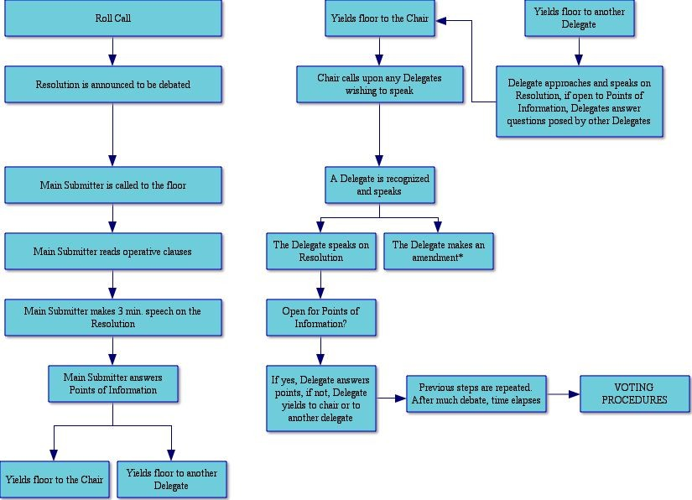

Voting Procedures

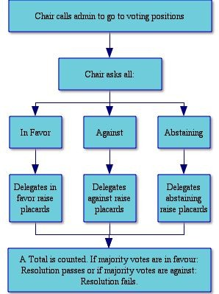

Amendment Process
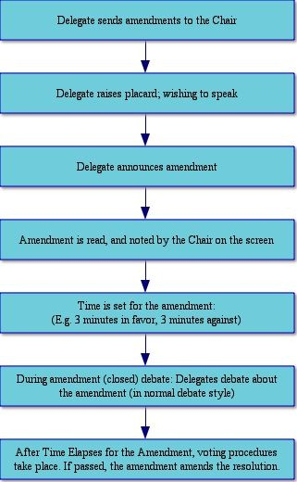

Lobbying & Merging Process
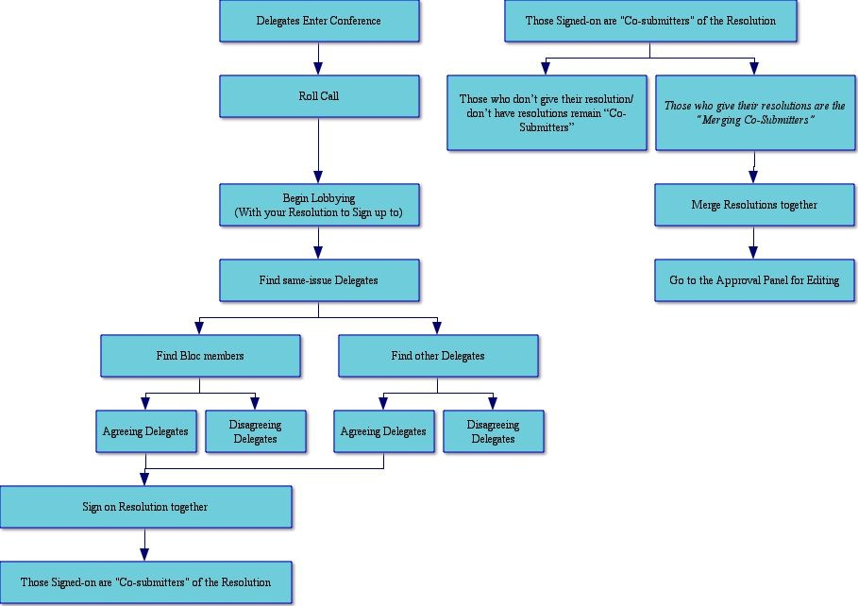

Resolution & Approval Panel Process

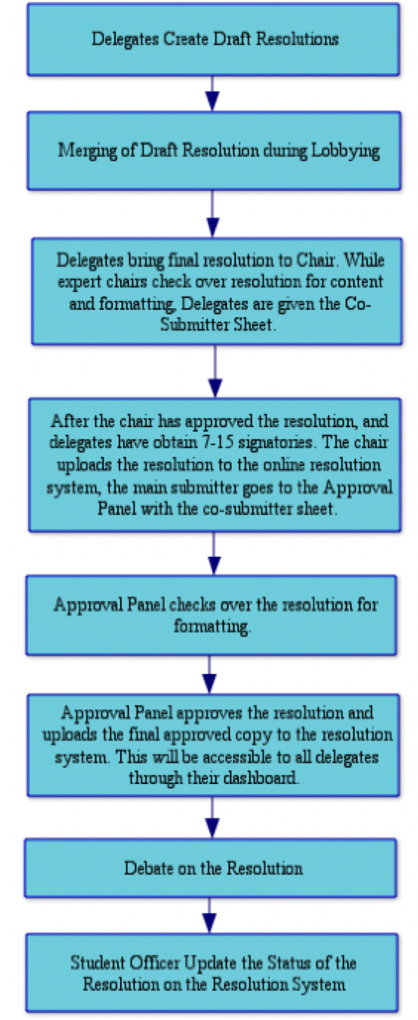
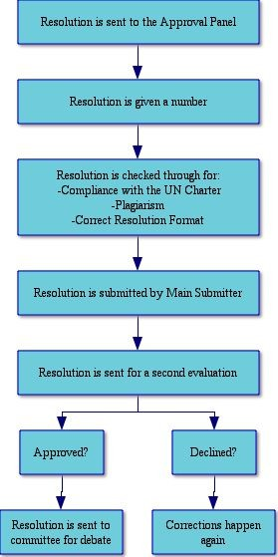

International Three-Letter Abbreviations
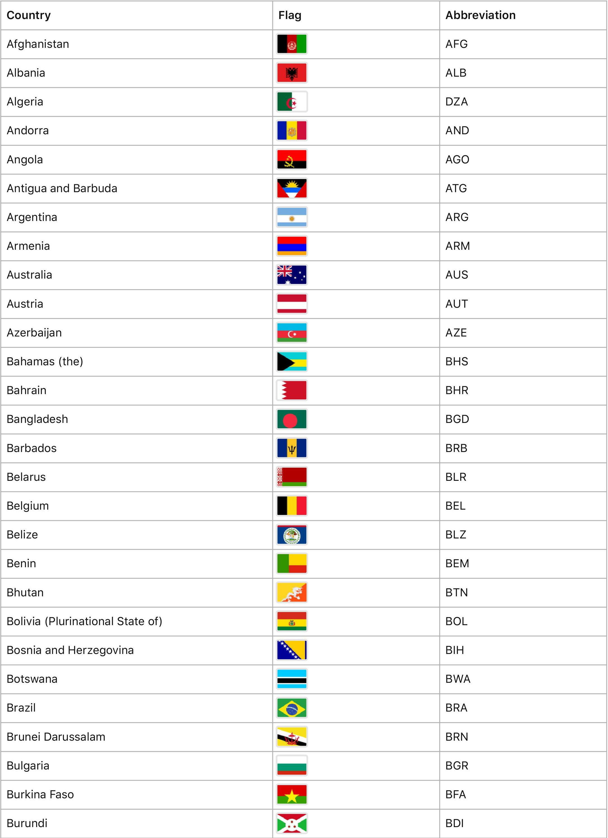

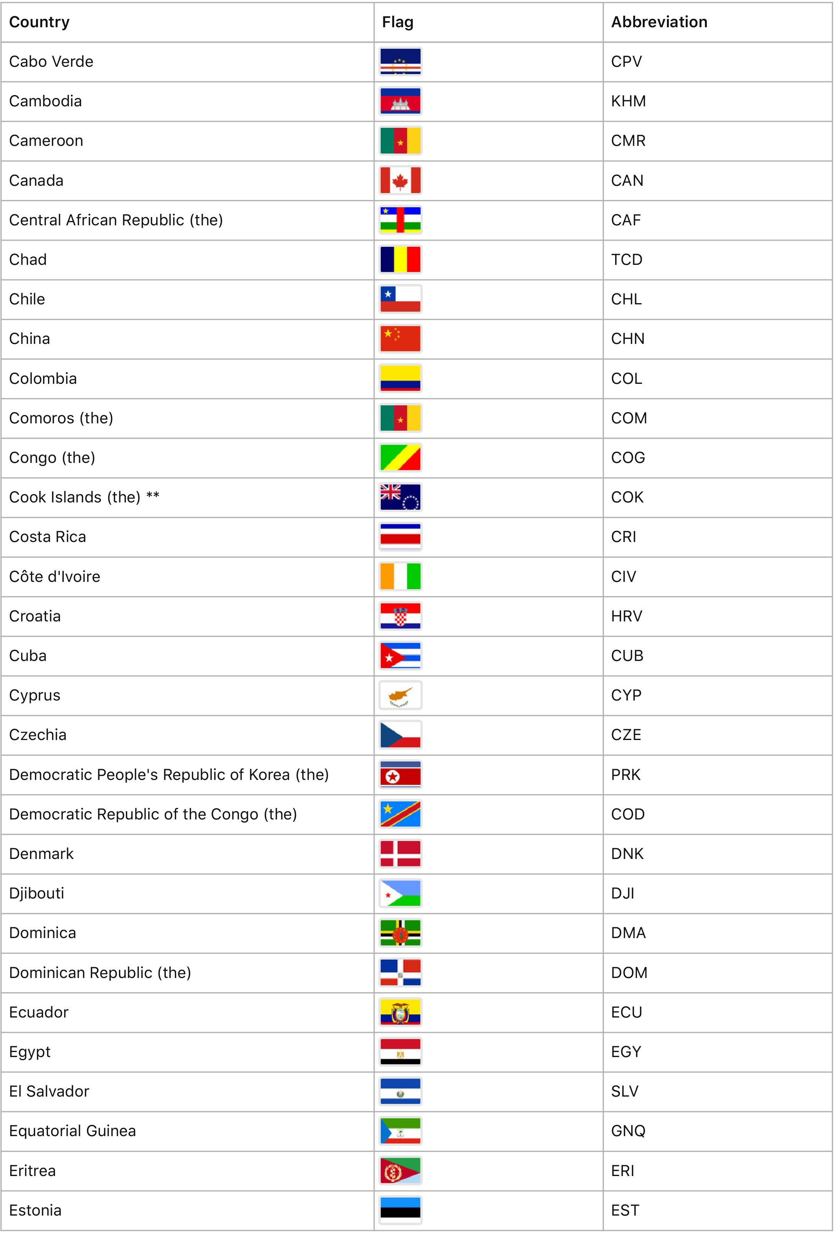

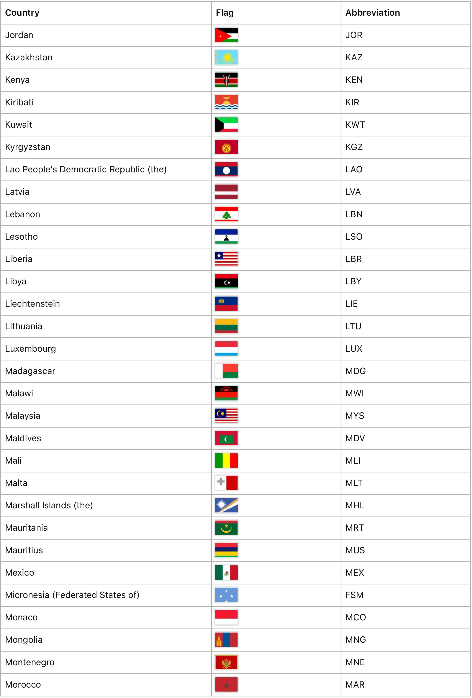

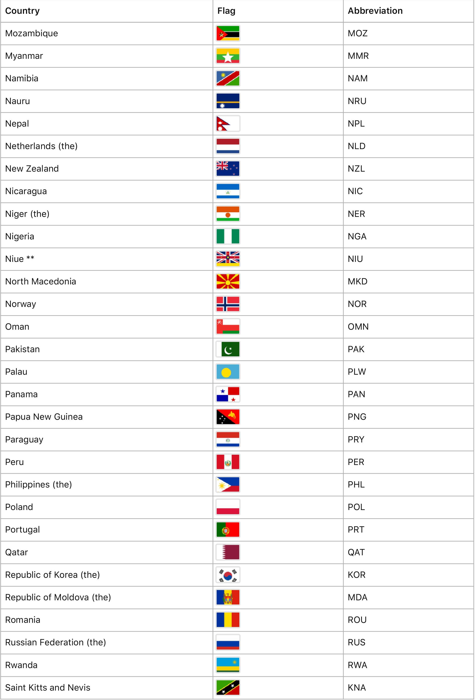

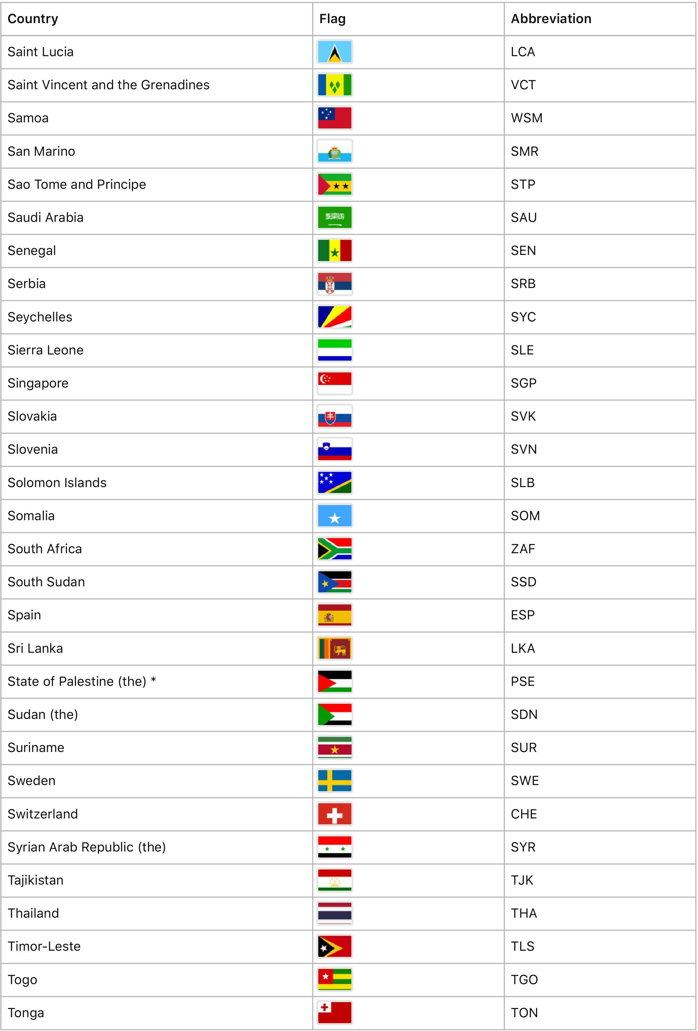

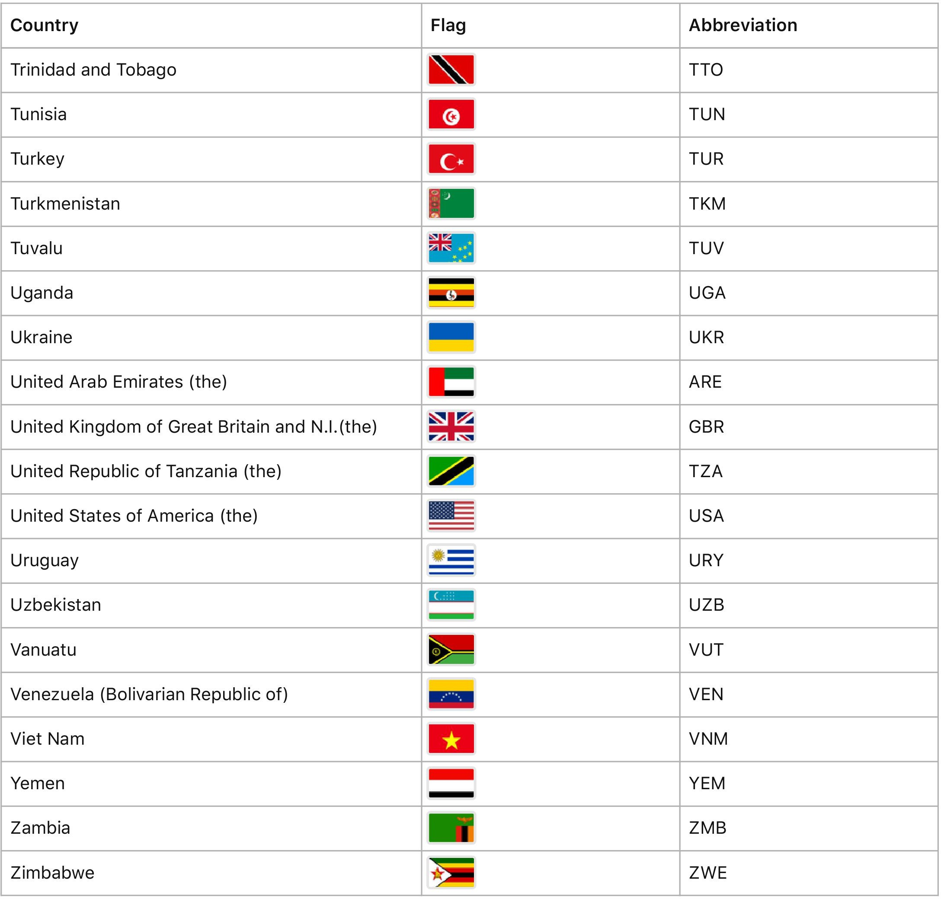
* Observer States
** Member of Specialized Agencies

  - APPLICATION

Rule 1
These rules of procedure apply to the proceedings of the all forums of the Beijing International Model United Nations as determined by the BEIMUN Directorate. For purposes of these rules, the words “General Assembly” are to be understood as referring to the BEIMUN General Assembly, its Committees, the forum in question or all forums collectively, as applicable. The word ‘committees’ may include other forums. The word “President” is to be understood to refer to the President of the General Assembly or the presiding officer in a given forum. The word “Chair” may also be used to refer to the presiding officer in a given forum, actual title notwithstanding.

Rule 2
All matters are conducted in accordance with these rules of procedure and rules of Parliamentary Order, with the former taking precedence over the latter.

  - SESSIONS

Rule 3
The General Assembly shall meet every year in session commencing on a date to be determined by the BEIMUN Directorate. The BEIMUN Directorate shall fix a closing date for the session.
BEIMUN Revised Rules of Procedure

Rule 4
The General Assembly shall meet in Beijing at a site to be determined by the BEIMUN Directorate.

  - AGENDA

Rule 5
The provisional agenda for a session shall be drawn up by the Secretary- General and communicated to the Members of the United Nations at least ninety days before the opening of the session.

Rule 6
The provisional agenda of a regular session shall include:
- The report of the Secretary-General;
- Reports from the Security Council, the Economic and Social Council, the International Court of Justice, the subsidiary organs of the General Assembly and the specialized agencies;
- All items proposed by the other principal organs of the United Nations;
- All items which the Secretary-General deems it necessary to put before the General Assembly.

Rule 7
Any Members of the United Nations or the Secretary-General may, at least sixty days before the date fixed for the opening of a session, request the inclusion of supplementary items in the agenda. Upon approval, such items shall be communicated to Members at least thirty days before the opening of the session.
  - DELEGATIONS

Rule 12
The delegation of a Member shall consist of not more than one representative per forum, except in the Security Council, where each Member shall have two representatives.

  - CREDENTIALS

Rule 8
Any item proposed for inclusion in the agenda shall be accompanied by an explanatory memorandum and, if possible, by basic documents or by a draft resolution.

Rule 9
All items on the agenda, except those deemed necessary by the Secretary-General, may be deleted or referred for consideration at the next session by the General Assembly by a majority of the members present and voting.

Rule 10
All items on the agenda shall be given priority by the Secretary-General.

Rule 11
Debate on a proposal to amend an item on the agenda shall be limited to one speaker in favor of, and one against, the amendment. The President may limit the time to be allowed to speakers under this rule.

Rule 13
The credentials of representatives and the names of members of a delegation shall be submitted to the BEIMUN Director before a date to be determined by the BEIMUN Directorate. The credentials shall be issued by the participating school through the Director of that school’s delegation.

  - PRESIDENT

Rule 14
Before the opening of each session of the General Assembly, the BEIMUN Directorate shall appoint a President, who shall hold office until the close of the session for which he/she is appointed.

Rule 15
If the President finds it necessary to be absent during a meeting or any part thereof, he/she shall designate a subordinate to take his/her place who shall have the same powers and duties as the President.

Rule 16
If the President is unable to perform his/her functions, a new President shall be appointed by the BEIMUN Directorate for the unexpired term.

Rule 17
In addition to exercising the powers conferred upon her/him elsewhere by these rules, the President shall, subject to the most recent program of events, declare the opening and closing of each plenary meeting of the session, the adjournment of the meeting, direct the discussions in plenary meeting, ensure observance of these rules, accord the right to speak, put questions and announce decisions. He/she shall rule on points of order and, subject to these rules, shall have complete control of the proceedings at any meeting and over the maintenance of order thereat. The President may, in the course of the discussion of an item, decide the limitation of the time to be allowed to speakers, the limitation of the number of times each representative may speak or the closure of the debate. He/she may also propose the suspension of the meeting or the adjournment of the debate on the item under discussion.

Rule 18
The President, in the exercise of his/her functions, remains under the authority of the Secretary-General, who shall be assisted by the Deputy Secretary- General and Under Secretary-General, and the BEIMUN Directorate.
  - GENERAL COMMITTEE

Rule 19
If there need be creation of such council, under advisement of the Secretariat, The General Committee shall comprise the President of the General Assembly, who shall preside and make the agenda for meetings of the committee, the Chairs of the committees and the Chairs of other forums which are to meet during the session.

Rule 20
The President of the General Assembly must be present at all meetings of the General Committee. The Chairs of the committees must be present at all meetings of the General Committee, unless they are exempted by the President of the General Assembly.

Rule 21
The General Committee shall assist the President and the General Assembly in drawing up the agenda for each plenary meeting, in determining the priority of its items and in coordinating the proceedings of all committees of the Assembly. It shall assist the President in the general conduct of the work of the General Assembly which falls within the competence of the President.

Rule 22
The General Committee shall meet periodically throughout each session to review the progress of the General Assembly and its committees and to make recommendations for furthering such progress. It shall also meet at such other times as the President deems necessary.

Rule 23
The General Committee may revise the resolutions adopted by the General Assembly, changing their form but not their substance.

  - ADMINISTRATION

Rule 24
The Under Secretary-General shall at his/her own discretion provide and direct the staff required by the General Assembly.
Rule 25
The Administrative Staff shall receive, print, and distribute documents, reports and resolutions of the General Assembly, its committees and its organs; prepare, print and circulate the records of the session; have the custody and proper preservation of the documents in the archives of the General Assembly; distribute all documents of the Assembly to the Members of the United Nations.

Rule 26
The Executive Committee shall establish regulations concerning Administrative Staff.

  - EXECUTIVE COMMITTEE

Rule 27
The Executive Committee shall comprise the Secretary-General, who shall preside and make the agenda for meetings of the committee, and the Deputy Secretary- General, Under Secretary-General, and President of the General Assembly.
Rule 28
The Secretary-General, in exercise of his/her functions, remains under the authority of the BEIMUN Directorate.

Rule 29
All decisions of the Secretary-General shall be taken in consultation and with the BEIMUN Directorate and in consensus with the Secretariat as a whole.

Rule 30
The Secretary-General shall act in that capacity in all meetings of the General Assembly and its committees. He/she may designate a member of the Office of the Secretary-General to act in his/her place at these meetings.

Rule 31
The Secretary-General shall make an annual report to the General Assembly on the work of the Organization. He/she shall communicate the annual report to the Members of the United Nations at least thirty days before the opening of the session.

Rule 32
The Secretary-General, with the consent of the Security Council, shall notify the General Assembly at each session of any matters relative to the maintenance of international peace and security which are being dealt with by the Security Council, and shall similarly notify the General Assembly immediately when the Security Council ceases to deal with such matters.

Rule 33
The BEIMUN Directorate shall establish regulations concerning the Executive Committee.

  - COMMISSION ON RULES OF PROCEDURE

Rule 34
The Executive Committee shall act as the Commission on Rules of Procedure. The Commission shall be chaired by the Secretary-General in consultation with the BEIMUN Director.

  - LANGUAGE

Rule 35
English shall be both the official and the working language of the General Assembly and its committees. All resolutions, records, and other documents shall be published in the language of the General Assembly.

  - RECORDS AND RESOLUTIONS

Rule 36
Summary records of the meetings of the General Assembly and its committees shall be drawn up by the Executive Committee, or its designates, and published after approval by the presiding officer.
Rule 37 Resolutions adopted by the General
Assembly and its committees shall be compiled by the Under Secretary- General and communicated by the Secretary-General to the Members after the close of the session.

  - MEETINGS OF THE GENERAL ASSEMBLY

Rule 38
The meetings of the General Assembly and its committees shall be held in public unless the organ concerned decides, with approval of the President, that exceptional circumstances require that the meeting be held in private.

Rule 39
All decisions of the General Assembly and its committees taken at a private meeting shall be announced at an early public meeting of the Assembly or committee.

Rule 40 Immediately after the opening of the
first plenary meeting and immediately preceding the closing of the final plenary meeting of each session of the General Assembly, the President may, at his/her discretion, invite the representatives to observe one minute of silence dedicated to prayer or meditation.

Rule 41
The General Assembly shall not make a final decision upon any item on the agenda until it has consulted an appropriate committee on that item.

Rule 42
Discussion of a report of a committee in a plenary meeting of the General Assembly shall take place if at least one third of the members present and voting at the plenary meeting consider such a discussion to be necessary. Any proposal to this effect shall not be debated but shall be immediately put to the vote.

Rule 43
The President may declare a meeting open and permit the debate to proceed when a quorum of at least one-third of the members of the General Assembly are present. The presence of a majority of the members shall be required for any decision to be taken.

Rule 44
No representative may address the General Assembly without having previously obtained the permission of the President. The President shall call upon speakers in an order determined by the President. The President may call a speaker to order if his/his remarks are not relevant to the subject under discussion.

Rule 45
A Rapporteur may be accorded precedence for the purpose of explaining the conclusions arrived at by that committee.
Rule 46
The Secretary-General, or a designated member of the Executive Committee, may at any time make either oral or written statements to the General Assembly concerning any question under consideration.

Rule 47
During the discussion of any matter, a representative may rise to a point of order, and the point of order shall be immediately decided by the President in accordance with these rules. A representative rising to a point of order may not speak on the substance of the matter under discussion. Debate will continue immediately following the President’s ruling. The President’s ruling will stand unless the Commission on Rules of Procedure, upon written appeal by a representative, deems otherwise. A decision of the President shall be reversed by the Commission on Rules of Procedure only if said decision has a demonstrable and egregious effect on the resolution of the question at hand or the integrity of the General Assembly.

Rule 48
The President may limit the time to be allowed to each speaker and the number of times each representative may speak on any question. When any representative exceeds his/her allotted time, the President shall call him/her to order without delay.

Rule 49
During the discussion of any matter, a representative may move the adjournment of the debate on the item under discussion. In addition to the proposer of the motion, two representatives may speak in favor of, and two against, the motion, after which the motion shall be immediately put to the vote. The President may limit the time to be allowed to speakers under this rule.

Rule 50
A representative may at any time move the closure of the debate or the item under discussion. Permission to speak on the closure of the debate shall be accorded only to two speakers opposing the closure, after which the motion shall be immediately put to the vote. If the General Assembly is in favour of the closure, the President shall declare the closure of the debate. The President may limit the time to be allowed to speakers under this rule.

Rule 51
During the discussion of any matter, a representative may move the suspension of the meeting. Such motions shall not be debated but shall be immediately put to the vote. The President may limit the time to be allowed to the speaker moving the suspension of the meeting.
Rule 52 Proposals according to BEIMUN
regulations shall be submitted in writing to the forum and shall be distributed to the delegations. As a general rule, no proposal shall be discussed or put to the vote at any meeting of the General Assembly unless copies of it have been circulated to all delegations. The President may, however, permit the discussion and consideration of motions as to procedure, even though such motions have not been circulated.

Rule 53 Amendments shall not be submitted during plenary meetings.

Rule 54
Any motion calling for a decision on the competence of the General Assembly to adopt a proposal submitted to it shall be put to the vote before a vote is taken on the proposal in question.

Rule 55
The President may, upon objection to a motion by any Member, deny the motion without discussion or vote by Members.

Rule 56
A motion may be withdrawn by its proposer at any time before voting on it has commenced. A motion thus withdrawn may be reintroduced by any member.

Rule 57
When a proposal has been adopted or rejected, it may not be reconsidered at the same session unless the General Assembly, by a two-thirds majority of the members present and voting, so decides. Permission to speak on a motion to reconsider shall be accorded only to two speakers opposing the motion, after which it shall be immediately put to the vote.

Rule 58
Each member of the General Assembly shall have one vote.

Rule 59
Decisions of the General Assembly on important questions shall be made by a two-thirds majority of the members present and voting. These questions shall include: recommendations with respect to the maintenance of international peace and security and the suspension of the rights and privileges of membership.

Rule 60
Decisions of the General Assembly, including the determination of additional categories of questions to be decided by a two-thirds majority, shall be made by a majority of the members present and voting.

Rule 61
For the purposes of these rules, the phrase “members present and voting” means members casting an affirmative or negative vote. Members which abstain from voting are considered as not voting.
Rule 62
The General Assembly shall normally vote by show of placards, but any representative may request a roll-call. The roll-call shall be taken in the English alphabetical order of the names of the members. The name of each member shall be called in any roll-call, and one of its representatives shall reply “yes”, “no” or “abstention”.

Rule 63
After the President has announced the beginning of voting, no representative shall interrupt the voting except on a point of order in connection with the actual conduct of the voting. The President may permit members to explain their votes, either before or after the voting. The President may limit the time to be allowed for such explanations. The President shall not permit the proposer to explain his/her vote on his/her own proposal.

Rule 64
A representative may move that parts of a proposal should be voted on separately. If objection is made to the request for division, the motion for division shall be voted upon. Permission to speak on the motion for division shall be given only to two speakers in favor and two speakers against. If the motion for division is carried, those parts of the proposal which are approved shall then be put to the vote as a whole. If all operative parts of the proposal have been rejected, the proposal shall be considered to have been rejected as a whole.

Rule 65
If two or more proposals relate to the same question, the General Assembly shall, unless it decides otherwise, vote on the proposals in the order in which they have been submitted. The General Assembly may, after each vote on a proposal, decide whether to vote on the next proposal.

Rule 66
If a vote is equally divided, the proposal shall be regarded as rejected.

  - COMMITTEES

Rule 67
The General Assembly may establish such committees as it deems necessary for the performance of its functions.

Rule 68
Items relating to the same category of subjects shall be referred to the committee or committees dealing with that category of subjects. Committees shall not introduce new items on their own initiative.

Rule 69
The Main Committees of the General Assembly are the following:
    - Disarmament and International Security Committee (First Committee)
    - Economic and Financial Committee (Second Committee)
    - Social, Humanitarian and Cultural Committee (Third Committee)
    - Special Political and Decolonization Committee (Fourth Committee)
    - Legal Committee (Sixth Committee).

Rule 70
Each Member may be represented by one person on each committee; Members of the Security Council are to be represented by two persons in that forum only.

Rule 71
Before the opening of each session, the Executive Committee shall appoint a President/Chair and up to three Deputies/Assistants, as deemed appropriate by the Executive Committee, for each committee, who shall hold office until the close of the session for which they are appointed.

Rule 72
If the Chair finds it necessary to be absent during a meeting or any part thereof, the Assistant/Deputy Chair shall take his/her place. An Assistant/Deputy acting as Chair shall have the same authority and duties as the Chair. If any officer of the committee is unable to perform his/her functions, a new officer shall be appointed by the Secretary-General for the unexpired term.

Rule 73
The Chair shall, subject to the most recent program of events, declare the opening and closing of each meeting of the committee, the adjournment of the meeting, direct its discussions, ensure observance of these rules, accord the right to speak, put questions, and announce decisions. He/she shall rule on points of order and, subject to these rules, shall have complete control of the proceedings at any meeting and over the maintenance of order thereat. The Chair may, in the course of the discussion of an item, decide the limitation of the time to be allowed to speakers, the limitation of the number of times each representative may speak, or the closure of the debate. He/she may propose the suspension of the meeting or the adjournment of the debate on the item under discussion.

Rule 74
The Chair, in the exercise of his functions, remains under the authority of the Executive Committee and the BEIMUN Directorate.

Rule 75
The Chair may declare a meeting open and permit the debate to proceed when a quorum of at least one-third of the members of the committee are present. The presence of a majority of the members shall be required for any decision to be taken.
Rule 76
No representative may address the committee without having previously obtained the permission of the Chair. The Chair shall call upon speakers in an order determined by the Chair. The Chair may call a speaker to order if his/her remarks are not relevant to the subject under discussion.

Rule 77
A Rapporteur of a committee or subcommittee may be accorded precedence for the purpose of explaining the conclusions arrived at by that committee or subcommittee.

Rule 78
The Secretary-General, or a designated member of the Executive Committee, may at any time make either oral or written statements to any committee or subcommittee concerning any question under consideration by it.

Rule 79
During the discussion of any matter, a representative may rise to a point of order, and the point of order shall be immediately decided by the Chair in accordance with these rules. A representative may appeal against the ruling of the Chair to the Commission on Rules and Procedure, as defined in Chapter X. The debate will continue and the Chair’s ruling shall stand unless overruled by the Commission. A representative rising to a point of order may not speak on the substance of the matter under discussion.

Rule 80
The Chair may limit the time to be allowed to each speaker and the number of times each representative may speak on any question. When the debate is limited and a representative exceeds his/her allotted time, the Chair shall call him/her to order without delay.

Rule 81
During the discussion of any matter, a representative may move the adjournment of the debate on the item under discussion. In addition to the proposer of the motion, two representatives may speak in favor of, and two against, the motion, after which the motion shall be immediately put to the vote. The Chair may limit the time to be allowed to speakers under this rule.

Rule 82
A representative may at any time move the closure of the debate on the item under discussion. Permission to speak on the closure of the debate shall be accorded only to two speakers opposing the closure, after which the motion shall be immediately put to the vote. If the committee is in favor of the closure, the Chair shall declare the closure of the debate. The Chair may limit the time to be allowed to speakers under this rule

Rule 83
During the discussion of any matter, a representative may move the suspension of the meeting. Such motions shall not be debated but shall be immediately put to the vote. The Chair may limit the time to be allowed to the speaker moving the suspension of the meeting.
Rule 84 Proposals according to BEIMUN
regulations shall be submitted in writing to the forum and shall be distributed to the delegations. As a general rule, no proposal shall be discussed or put to the vote at any meeting of the committee unless copies of it have been circulated to all delegations. The Chair may, however, permit the discussion and consideration of motions as to procedure, even though such motions have not been circulated.

Rule 85 Amendments shall be submitted in writing during committee meetings.

Rule 86
Any motion calling for a decision on the competence of the General Assembly or the committee to adopt a proposal submitted to it shall be put to the vote before a vote is taken on the proposal in question.

Rule 87
The Chair may, upon objection to a motion by any Member, deny the motion without discussion or vote by Members.

Rule 88
A motion may be withdrawn by its proposer at any time before voting on it has commenced, provided that the motion has not been amended. A motion thus withdrawn may be reintroduced by any member.

Rule 89
When a proposal has been adopted or rejected, it may not be reconsidered at the same session unless the committee, by a two-thirds majority of the members present and voting, so decides.
Permission to speak on a motion to reconsider shall be accorded only to two speakers opposing the motion, after which it shall be immediately put to the vote.

Rule 90
Each member of the committee shall have one vote.

Rule 91
During circumstances of double delegations, an agreement must be reached among the contentious delegates and represent the member state as a whole to put forth a vote.

Rule 92
Decisions of committees shall be made by a majority of the members present and voting.

Rule 93
The committee shall normally vote by show of placards, but any representative may request a roll-call. The roll-call shall be taken in the English alphabetical order of the names of the members, beginning with the member whose name is drawn by lot by the Chair. The name of each member shall be called in any roll-call, and its representative shall reply “yes”, “no”, or “abstention”.
Rule 94
After the Chair has announced the beginning of voting, no representative shall interrupt the voting except on a point of order in connection with the actual conduct of the voting. The Chair may permit members to explain their votes, either before or after the voting. The Chair may limit the time to be allowed for such explanations. The Chair shall not permit the proposer of a proposal or of an amendment to explain his/her vote on his/her own proposal or amendment.

Rule 95
A representative may move that parts of a proposal or of an amendment should be voted on separately. If objection is made to the request for division, the motion for division shall be voted upon. Permission to speak on the motion for division shall be given only to two speakers in favor and two speakers against. If the motion for division is carried, those parts of the proposal or of the amendment which are approved shall then be put to the vote as a whole. If all operative parts of the proposal or of the amendment have been rejected, the proposal or the amendment shall be considered to have been rejected as a whole.

Rule 96
When an amendment is moved to a proposal, the amendment shall be voted on first. If one or more amendments are adopted, the amended proposal shall then be voted upon. A motion is considered an amendment to a proposal if it merely adds to, deletes from, or revises part of the proposal.

Rule 97
If a vote is equally divided the proposal shall be regarded as rejected.

  - ADMINISTRATIVE AND BUDGETARY QUESTIONS

Rule 98
No resolution shall include either financial amounts or names of specific financial resources.
  - SUBSIDIARY ORGANS OF THE GENERAL ASSEMBLY

Rule 99
The General Assembly may establish such subsidiary organs as it deems necessary for the performance of its functions. The rules relating to the procedure of committees of the General Assembly shall apply to the procedure of any subsidiary organ unless the Assembly or the subsidiary organ, with approval of the Assembly, decides otherwise.

  - AMENDMENTS TO THE BEIMUN RULES OF PROCEDURE

Rule 100
These rules of procedure may be amended by a decision of the BEIMUN Directorate in consultation with the Executive Committee at any time necessary prior and during the conference.

The BEIMUN Rules of Procedure have been adapted from the THIMUN Revised Rules of Procedure of 2006 <http://thimun.org> for the sole purpose of the Beijing Model United Nations (BEIMUN) annual conference. Revised in 2017. First proposed and adopted by Ean Burchell in 2009.

Appendix

Appendix 1: Secretariat Team – Areas of Responsibility
BEIMUN XXVIII 2021 Secretariat Team Members & Responsibilities
Name | Positions | Commission Supervision and Responsibilities
Sally Kim | Co-Secretary General | All Areas, DIS, SC
George Xu | Co-Secretary General | All Areas, ENV, HSC, WHA
Edward Zeng | Deputy Secretary General | GA2, ECOSOC
Nan Jiang | Deputy Secretary General | GA1, GA3, WHA

Appendix 2: Head Admin Officers

Name | Title
Alice Xu | Head Admin Officer
Nan Jiang | Head Admin Officer

–––––––––––––––––––––––––––– BEIMUN XXX –––––––––––––––––––––––––––

